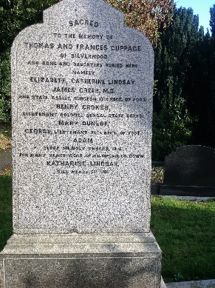Ref: A/001 - **CUPPAGE**

Sacred to the memory of THOMAS and FRANCES CUPPAGE of Silverwood and sons and daughters buried here, namely ELIZABETH CATHERINE LINDSAY; JAMES GREER (CUPPAGE) M.D. Asst. Surgeon, 17th Regiment of Foot; LT. COLONEL HENRY CROKER (CUPPAGE), Bengal Staff Corps; MARY DUNLOP; LT. GEORGE (CUPPAGE), 70th Regiment of Foot; (Rev.) ADAM (CUPPAGE), M.A. Clerk in Holy Orders, for many years Vicar of Kilmegan, Co. Down; KATHERINE LINDSAY died 9th March, 1911.

Ref: A/002 – **WALSHE**

Ref: A/003 – Vacant

Ref: A/004 – Vacant

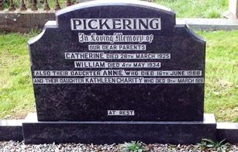Ref: A/005 – **PICKERING**

In loving memory of our dear parents

CATHERINE, died 28th March, 1925 and

WILLIAM, died 4th May, 1934. Also their daughter

ANNE who died 16th June 1988 and their daughter

KATHLEEN CHARITY who died 9th March 1991. At Rest.

Ref: A/006 - **RICHARDSON**

Ref: A/007 - **HOLLIDAY**

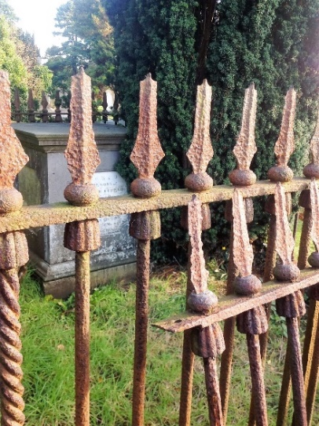Ref: A/008 – **CUPPAGE**

*Square monument* – covered in ivy – inside iron railings. Sacred to the memory of ALEXANDER CUPPAGE who departed this life ??th December 1851 aged 66 years, most sincerely and deservedly beloved, respected and regretted. Also of ANN, his wife who died the 24th of May, 1862 in the 71st year of her age. *Left side of monument* – Here rest the remains of HENRY, third son of ALEXANDER and ANN CUPPAGE. Born 11th February 1799, died 11th February 1862. Jesus said unto her, Thy brother shall rise again. John 23 v.1*Right side of monument* –Sacred to the his wife MARIA, died1889 aged 71 years, and their children, BURKE, died 1858 aged 7 years; Lieut. ALEXANDER 102 Royal Madras Fusiliers, killed at Cannanore, India, 1864, aged 25 years; ADAM, died 1870 aged 25; JOHN ALBERT, died 1870 aged 28 years; HENRY, S.I.R.I.C. died 1876 aged 33 years.

Ref: A/009 – Vacant

Ref: A/010 - **HEWITT**

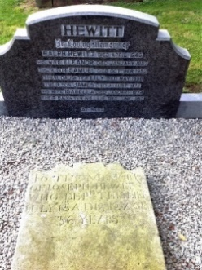In loving memory of RALPH HEWITT, died April, 1945. His wife ELEANOR, died January, 1957. Their son, SAMUEL, died October 1952. Their daughter, LILY, died May, 1958. Their son, JAMES, died August, 1972. His wife, ISABELL, died January, 1974. Their daughter, NELLIE, died June, 1953.

*Slab resting on grave reads:* To the memory of JOSEPH HEWITT who departed this life July 15th, 1812 aged 36 years.

Ref: A/011 – **HEWITT** (unmarked) “Taghnevin”

Ref: A/012 – Vacant

Ref: A/013 – **ANDERSON** (unmarked)

Ref: A/014 – **TURKINGTON** (unmarked)

Ref: A/015 – **GRAHAM** of Lough Road

Ref: A/016 - **BROWN**

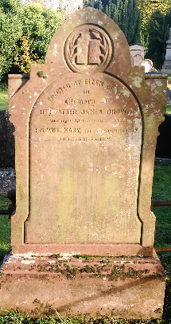Erected by ELLEN BROWN in memory of her father JAMES BROWN who died 29th October 1832. His wife, MARY, died 3rd November 1832 and their family

Ref: A/017 – Vacant

Ref: A/018 - **MILLAR**

In loving memory of WILLIAM MILLAR who departed this life 20th August, 1930. Also his wife, MARY A. MILLAR who departed this life 28thJanuary, 1952

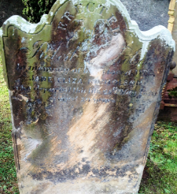Ref: A/019 – **NICHOLSON**

Erected by ROBERT NICHOLSON in memory of his beloved wife JANE ELIZA NICHOLSON who departed this life 20th May, 1850 aged 30 years.

Ref: A/020 – **BURNS** (unmarked)

Ref: A/021 – Vacant

Ref: A/022 – Vacant

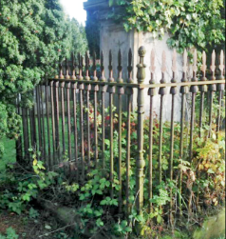Ref: A/023 – **UPRICHARD**

Stone monument within rusted railings. Writing illegible.

Ref: A/024 – **PRICE & RUSSELL**

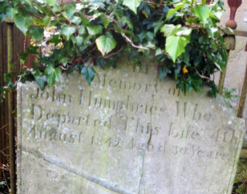Ref: A/025 - **HUMPHRIES**

In memory of JOHN HUMPHRIES who departed this life 4th August, 1832, aged 30

Ref: A/026 – **HUME** (Unmarked) Dr. Hume

Ref: A/027 – Unknown

Ref: A/028 - **LONSDALE** (Unmarked)

Ref: A/029 – **McGLADDERY** (Unmarked)

Ref: A/030 – **PENTLAND** (Unmarked)

Ref: A/031 – **McCOURT**

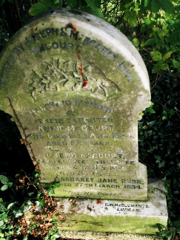Erected by JOSEPH and MARGARET JANE in loving memory of their daughter, ANNIE McCOURT who died 16th August 1924 aged 22 years. Also the above JOSEPH McCOURT who departed this life on 4th May 1928 aged 85 years. Also MARGARET JANE RUSK, who died 27th March, 1934.

“Till He come”

Ref: A/032 – **WILSON** (Unmarked)

Ref: A/033 - **HANNAH & STEWART** (Interments 10/01/34 – 18/02/39 – 19/12/41)

Ref: A/034 – Vacant

Ref: A/035 - **BUNTER** of Donegragh (Unmarked)

Ref: A/036 – Vacant

Ref: A/037 – **LAVERY** (Unmarked)

Ref: A/038 – Vacant

Ref: A/039 - Vacant

Ref: A/040 – **REID** (Unmarked)

Ref: A/041 – **HAZELY** (Unmarked)

Ref: A/042 – Vacant

Ref: A/043 – **KERR** (Unmarked)

Ref: A/044 – **HAIGH** (Unmarked) Schoolmaster interred 23/04/1935

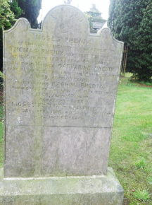Ref: A/045 - **PHENIX**

Erected by MOSES PHENIX of Lurgan in memory of his father THOMAS who departed this life the 18th May 1837 aged 64 years. Also his mother, CATHERINE PHENIX, who departed this life 9th February 1859 aged 60 years. Also his wife RACHEL PHENIX who departed this life the 6th October 1864 aged 47 years. The above named MOSES PHENIX who departed this life 22nd April 1880 is also interred ere aged 62 years.

Ref: A/046 – **HANNA** (Unmarked)

Ref: A/047 – **PEDLOW** (Unmarked)

Ref: A/048 – Vacant

Ref: A/049 – **CONN** (Unmarked)

Ref: A/050 – **WATSON**

“I, the Lord, am thy Saviour and thy Redeemer.” Isaiah XL1 v. 24.

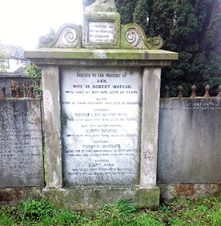Sacred to the memory of ANN, wife of ROBERT WATSON who died 1st May 1831 aged 49 years. Also four of their children who died in infancy. Likewise ISABELLA, his second wife, who died 25th May, 1840 aged 43 years and the above ROBERT WATSON who died 18th July 1848 aged 72 years. Likewise FRANCIS WATSON, eldest son of the above named ROBERT WATSON, who died 16th October 1877 aged 68 years. Likewise MARY JANE, wife of the above named FRANCIS WATSON, who died 17th December, 1885 aged 69 years.

*Left side Tablet:* Also the children of FRANCIS and MARY WATSON. WILLIAM WATSON, died 18th December 1846 aged 11 months. JANE WATSON died 28th August 1854 aged 11 months. ARTHUR WELLESLEY WATSON died 6th October 1854 aged 2 years. MARTHA STUART WATSON died 19th March 1970 aged 11 years. WILLIAM WATSON died 8th September 1875 aged 23 years. FRANCIS WATSON died 14th June 1901 aged 55 years. ROBERT WATSON died 22nd May 1913. THOMAS WATSON died 25th January 1925 aged 70 years. *Right side Tablet:* JOSEPH STUART WATSON died 3rd February 1935 aged 86 years.

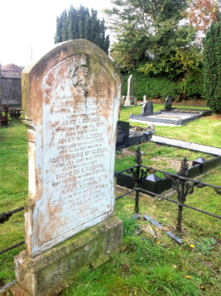Ref: A/051 – **LAWSON/HENRY**

Erected by ALEXANDER LAWSON of Lurgan in memory of his father, ALEXANDER LAWSON, who died 24th January 1842, also his mother, JANE LAWSON, who died 7th April 1852. Also his sister, MARY McCLEERY who died October 1828 and also his nephew, ALEXANDER McCLEERY who died 31st May 1860. Also his brother THOMAS LAWSON, who died 15th March 1864, also his sister, ANN LAWSON, who died 8th April 1883; also the above named ALEXANDER LAWSON, who died 25th September 1888 aged 80 years. MARGARET LAWSON, died 24th October 1902, aged 90 years. *Left side Tablet:* MARY A. HENRY*,* wife of THOMAS HENRY*,* who departed this life 16th August 1928 and of their daughter, MARY UPRICHARD, who departedthis life 24th August 1953. Also her husband, WILLIAM HENRY, who departed this life 18th October 1975 aged 84 years*.* *Right side Tablet:* THOMAS HENRY who departed this life 1st March 1930, also their daughter, MABEL, who departed this life 5th October 1956. ELIZABETH HENRY, died 24th July 1978.

Ref: A/052 – **McDOWELL** (Unmarked).

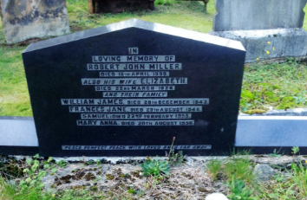Ref: A/053 - **MILLER**

In loving memory of ROBERT JOHN MILLER, died 15th April 1900, also his wife, ELIZABETH, died 22nd March 1926 and their family; WILLIAM JAMES died 20th December 1943; FRANCES JANE, died 29th August 1946, SAMUEL, died 22nd February 1955, MARY ANNE, died 20th August 1956. “Peace, perfect peace with loved ones far away.”

Ref: A/054 – Vacant

Ref: A/055 – Vacant

Ref: A/056 – **CALVERT** (Unmarked).

Ref: A/057 – **YOUNG** (Unmarked).

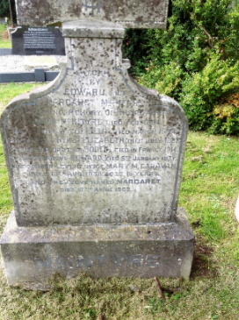Ref: A/058 – **McINTYRE**

Erected by EDWARD and MARGARET McINTYRE in loving memory of their father, JAMES McINTYRE, died February 1894. Also their sister, LILLIE, died March 1894, and their mother, ELIZABETH, died July 1897. Also their brother, ROBERT, died in France 1914. Also the above named EDWARD died 5th January 1937. Also their loving niece, MAY M. CANAVAN, died 15th August 1938 aged 15 years and the above named MARGARET died 17th April 1962’

“R.I.P.”

Ref: A/059 – **SCOTT**

W.J. SCOTT died 11th January 1957. Interment ?? 31st October 1980

Ref: A/060 – **FURPHY**

Interment – 26th June 1952 J. Furphy 11th October 1960

**Ref: A/061 -** BYRNE

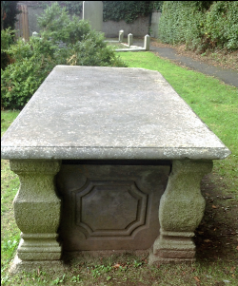Underneath this tomb lie the remains of the late JAMES BYRNE of Kinnego, who departed this life on the 8th December 1818 aged 65 years.

Erected to the memory of the late MARY ANN ACKINSON, wife of BENJAMIN ACKINSON of Ballynewry, Co. Armagh, Esq., daughter of the above named J. BYRNE, who departed this life on the 8TH March 1894 in the 87th year of her age.

Ref: A/062 – **BURNS** (Unmarked)

Ref: A/063 – **CAPPER** (Unmarked)

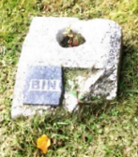Ref: A/064 – **BINGHAM**

Vandalised memorial vase is only marker.

Interments: 11 July 1932; 16 May 1938; 27 May 1938; 9 April 1962

Ref: A/065 Vacant

Ref: A/066 – **BUNTING** (Unmarked) Interment 13 December 1935

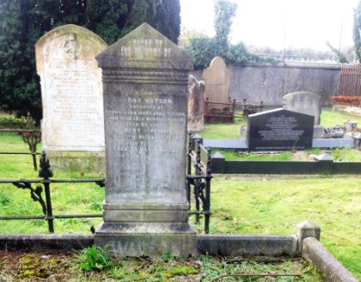Ref: A/067 – **WATSON**

Sacred to the memory of SARAH WATSON, daughter of FRANCIS and MARY JANE WATSON, who died 10th November 1936, aged 80 years. MARY WATSON, died 11th December 1939, aged 92. FRANCES MARIA WATSON, died 26th February 1940 aged 83 years. CAROLINE WATSON died 29th June 1957 aged 97 years. ALICE WATSON died 1st December 1957, aged 94 years.

“Till He Come.”

Ref: A/068 – **COOPER** (Unmarked)

Ref: A/069 – **McCANN/HANNA**

Ref: A/070 - **MAGINN**

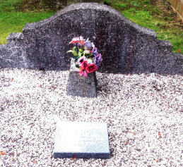George Maginn

Nurse Maginn (Midwife)

Ref: A/071 – Vacant

Ref: A/072 – Vacant

Ref: A/073 – Vacant

Ref: A/074 – **CULLY** (Unmarked)

Ref: A/075 – Vacant

Ref: A/076 – Vacant

Ref: A/077 – **IRWIN** (Unmarked)

Ref: A/078 – **ANDERSON** (Unmarked) Interments 28 July 1934; 18 January 1943; 19 February 1951

Ref: A/079 – **MATCHETT** (Unmarked)

Ref: A/080 – **MATHERS**

*Tombstone on left of Main stone:*  In memory of RICHARD OVEREND who departed this life February 1795 aged 66 years and ELZABETH, his wife who departed this life February 1795 aged 64 years. Also their daughters, JANE who departed this life December 1847 aged 82 years; ELIZABETH who departed this life December 1847 and MARY who departed this life Sept 1863 aged 93 years.

*Main stone:* In loving memory of ROBERT MORRIS died June 2nd 1878 aged 78 years and of his beloved wife JANE MORRIS died December 16th 1891 aged 86 years. Erected by their attached daughters. Also to the loving memory of MATHERS MORRIS died December 8th 1846 aged 5 years and THOMAS MATHERS died May 4th 1870 aged 35 years, sons of the above*. “I know that my Redeemer liveth.” Job X1X 25*

*Footstone:* In memory ofTHOMAS MORRISwho departed this life 3rd May 1870 aged 35 years after a short illness. Lamented by a large circle of relatives and friends to whom his many virtues had greatly endeared him. This tablet has been erected by his bereaved widow, HENRIETTA SARAH MORRIS.  *“Therefore be ye also ready for in such an hour that you think not the Son of Man cometh.”*

*Tombstone to right of Main stone*:THOMAS OVEREND departed this life 22nd March 1801 aged 76 years. ELIZABETH OVEREND, wife of the above, departed this life the 1st January 1815 aged 90 years*. “Sheltered beneath the almighty wings they both securely rest.”*

THOMAS MORRIS departed this life 16th of April 1813 aged 42 years*. “The sweet remembrance of the just will flourish when he steps in the dust.”* JANE MORRIS departed this life 1st of May 1817 aged 70 years*. “Blessed are the dead who die in the Lord, they rest from their labours and their works shall follow them.”* THOMAS, son of the above THOMAS MORRIS, who departed this life August 1827 aged 80 years. Also ANNE, wife of the first named THOMAS MORRIS, who died the 11th July 1839 aged 73 years and ELIZABETH, daughter of the above named THOMAS MORRIS, who died 25th March 1878 aged 76 years.

Ref: A/081 - **HILL**

1. 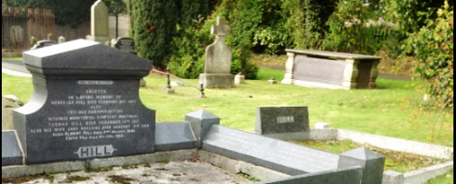Inscription – HILL
2. *“Thy will be done.”*

*On sidings of surround*: WILLIAM HILL, beloved husband of ANN JANE HILL, died October 14th 1948 and his wife, ANN JANE, died 29th April, 1982. Also their son, Sgt WILLIAM J. HILL, killed in action March 2nd 1944, interred in Military Cemetery at Durnbach, Germany. Erected in loving memory of AGNES LEE HILL, died February 8th 1917; also FRED, died December 29th 1915, interred Mount Royal Cemetery, Montreal. THOMAS HILL died December 15th 1917, also his wife JANE ADELAIDE, died January 9th 1938; also ALBERT HILL, died 2nd March, 1961. EDITH HILL, died April 6th 1962.

Ref: A/081 (c) – **BALL?** (Unmarked) Jane – interred 6th November 1936

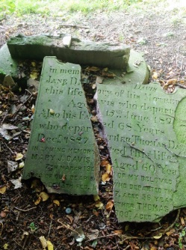Ref: A/082 – **DAVIS**

Erected by ANDREW DAVIS in memory of his mother who departed this life 15th June 1825 aged 68 years. Also his father, THOMAS DAVIS, who departed this life 14th December 1827 aged 60 years.

In loving memory of my beloved wife, MARY J. DAVIS who departed this life 7th March 1907, aged 58 years. Also our dear father THOMAS DAVIS who departed this life 13th February 1909, aged 69 years. Also our dear brother, THOMAS DAVIS who departed this life 31st August 1919 aged 34 years.

Ref: A/083 – **McILWAINE** (Unmarked)

Ref: A/084 – **MACOUN**

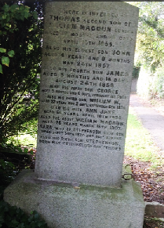Here is interred THOMAS, second son of WILLIAM MACOUN, Lurgan, aged 10 months and 25 days, April 18th 1855. Also his eldest son, JOHN, 4 years and 9 months, May 24th 1857. Also his fourth son JAMES, aged 5 months and 16 days, August 24th 1858. Also his fifth son GEORGE aged 9 months and 6 days, February 1st 1860. Also his third son WILLIAM W., aged 22 years and 9 days, September 6th 1878. Also his wife, ANN JANE, aged 66 years, April 10th 1896. Also the above WILLIAM MACOUN, aged 76 years, March 15th 1907. SARA, wife of STEPHENSON, sixth son, born September 30th 1872, died October 11th 1911. Also his sixth son, STEPHENSON, born May 26th 1861, died January 7th 1929.

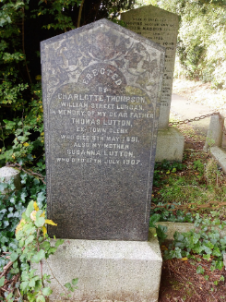Ref: A/085 **- LUTTON**

Erected by CHARLOTTE THOMPSON, William Street, Lurgan. In memory of my dear father THOMAS LUTTON, ex Town Clerk, who died 8th May 1891. Also my mother SUSANNA LUTTON who died 17th July 1907.

Ref: A/086 – **MOORE** (Unmarked)

Ref: A/087 – **PELAN**

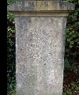

REBECCA PELAN died February 21st 1855 aged 15 months. ELEANOR ANN died July 31st 1855 aged 5 months. REBECCA ANN died April 6th 1870 aged 13 years 5 months. JAMES PELAN died November 14th 1876 aged 87.

JOHN PELAN, father of above children, taken home 12th February 1880 aged 66 years. ELEANOR PELAN, his wife, taken home 8th February 1887 aged 63 years.

Ref: A/088 – **TOMLINSON** (Unmarked)

Ref: A/089 – **MATHERS**

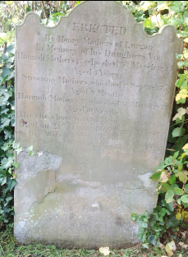Erected by **HENRY MATHERS** of Lurgan in memory of his daughters viz. HANNAH MATHERS (1) who died 3rd March 1825 aged 5 years; SUSANNA MATHERS who died 1st September 1827 aged 9 months; HANNAH MATHERS (2) who died 31st March 1829 aged 10 months. Also the above named HENRY MATHERS died 21st January 1860 aged 74 years. His wife, ANN JANE, who died 1871, and his son JOHN, who died 23rd April 1895.

Ref: A/090 – **POLLOCK**

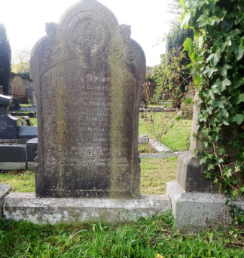**(**Two stones in one plot – Oldest stone covered in ivy 2015).

Sacred and in loving memory of MARY JANE POLLOCK who died December 24th 1884 aged 47 years. Also GEORGE POLLOCK who died May 4th 1901 aged 64 years. Also their youngest son ALBERT MELANOTHAN who died at Vancouver, B.C. December 28th 1911 aged 30 years. Also their son JOHN WYCLIFFE who died July 31st 1955 aged 81 years. Also his wife ELIZA ANN who died 29th December 1959*. “Sleep on beloved, sleep and take thy rest, we loved thee well but Jesus loved thee best. Goodnight.”*

*“Till He Come.”*

In loving memory of FREDERICK WILLIAM POLLOCK, (Town Clerk)died21st December 1921 aged58years. Alsohis wife ALISON BARCLAY, died 17th July 1947 aged 88 years. Also their daughters ETHEL FLORENCE died 16th January 1901 aged 4 years; ALISON BARCLAY died 17th April 1956 aged 67 years. Also their daughter in law, MABEL POLLOCK, who died 15th April 1969 aged 74 years; also their son HENRY TREVOR POLLOCK, and husband of the above MABEL, died 18th May 1983 aged 86 years.

Ref: A/091 – Vacant

Ref: A/092 – Vacant

Ref: A/093 - **BRASSFIELD** {Unmarked)

Ref: A/094 – **CAMPBELL**

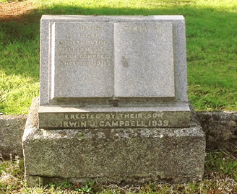In loving memory of my dear father and mother WILLIAM and SARAH CAMPBELL who died 1911. Erected by their son IRWIN J. CAMPBELL 1939.

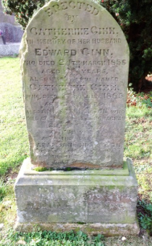Ref: A/095 – **GINN**

Erected by CATHERINE GINN in memory of her husband EDWARD GINN, who died 24th March 1858 aged 49 years. Also the above named CATHERINE GINN who died 22nd July 1885 aged 78 years.

Also ANNIE NICHOLSON who died at Claverhill, Co. Monaghan 21st June 1893 aged 93 years.

Also their daughter SARAH JANE NICHOLSON who departed this life 15th January 1828 aged 56 years.

Ref: A/096 – Vacant

Ref: A/097 - **ARMSTRONG**

*(Note: This Memorial has been severely vandalised since originally surveyed in 1987/88. These photographs were taken in October 2015).*

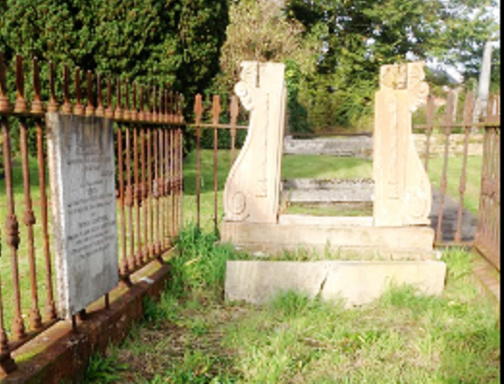

In memory of PHOEBE ARMSTRONG, who departed this life 23rd July 1834, aged 75 years. WILLIAM ARMSTRONG who departed this life 15th August 1835 aged 74 years*. “The memory of the just men smells sweet and blossoms in the dusk.”* WILLIAM ARMSTRONG who departed this life 28th April 1871 aged 81 years. ROSE ARMSTRONG, the beloved wife of WILLIAM ARMSTRONG, the above named, who departed this life 28th July 1879. *“The love of God was in her heart, His praise on her lips, and feeding daily on the hope of Heaven, Christian faith calmed the fear in her soul.”*

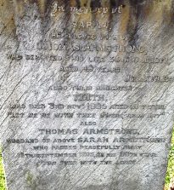In memory of SARAH, the beloved wife of THOMAS ARMSTRONG, who departed this life 39th April 1871 aged 49 years. *John XV11 24.*

Also their daughter EDITH who died 3rd November 1895 aged 31 years.

*“Let me be with Thee where Thou art.”*

Also THOMAS ARMSTRONG, husband of the above SARAH ARMSTRONG who passed peacefully away. 18th September 1916, in his 98th year. *“For ever with the Lord.”*

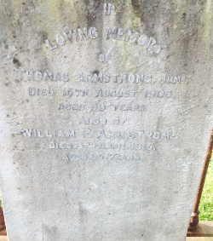

In loving memory of THOMAS ARMSTRONG JUNR*,* died 15th August 1906, aged 60 years; also WILLIAM F. ARMSTRONG, died 8th April 1915, aged 65 years.

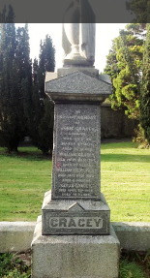Ref: A/098 – **GRACEY**

*(Marble plinth with urn on top inscribed on all sides).*

In loving memory of JOHN GRACEY, Drumgor, who died on March 4th 1892, aged 76 years*.* WILLIAM GRACEY died November 24th 1897, aged 57 years*.* WILLIAMFREDERICK GRACEY died September 22nd 1880, aged 6 months. SARAH GRACEY died April 21st 1906, aged 90 years.

Inloving memory of JAMES GRACEY who departed this life 15th February 1907 aged 53 years. HARRISON GRACEY, who departed this life 24th June 1924, aged 72 years*. “Come unto Me all ye that labour and are heavy laden, and I will give you rest.”*

In loving memory of HOWARD DONALD, son of J.G. GRACEY, who died 19th March 1928 aged 16 months. Also MARGARET BELL GRACEY, wife of W. GRACEY, who died 21st January 1928, aged 78 years. Also JOHN GRACEY, who died 4th December 1924, aged 82 years. Also THOMAS VICTOR, son of J.G. GRACEY, died 29th March 1941.

In memory of WILLIAM FREDERICK GRACEY who departed this life 20th June 1925, aged 43 years. Also ELIZABETH GRACEY who departed this life 8th October 1913. Also ROBERT GRACEY who departed this life 17th August 1915 aged 72 years. *“The Master is gone and calleth to thee,” St, John 11.88*.

Also the above J. G. GRACEY died 23rd January 1959 aged 80 years. Also WILLIAM ALFRED GRACEY, son of J.G. GRACEY, died 15th May 1970.

Ref: A/099 - Vacant

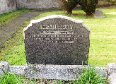Ref: A/100 – **McMURRAY**

In loving memory of my dear mother MAIE, died 7th May 1960. Also her father, ROBERT IRWIN, died 19th February 1950.

Ref: B/101 – **CULLY** (Unmarked)

Ref: B/102 – Vacant

Ref: B/103 – **LAVERY** (Unmarked)

Ref: B/104 – **HUGHES/RICE** (Unmarked)

Ref: B/105 – **LAVERY** (Unmarked)

Ref: B/106 – Vacant

Ref: B/107 = **CASTLES** (Unmarked)

Ref: B/108 – **HETHERINGTON** (Unmarked)

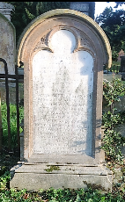Ref: B/109 – **ANDERSON**

In memory of JOSEPH W. ANDERSON, an idolised son, died 23rd November 1864, in the 24th year of his age. *“Oh blessed are they who live and die.”*

Also of MARGARET ANDERSON, mother of the above named JOSEPH W. ANDERSON, who died on 13th day of May 1883, aged 77 years. Also of JAMES ANDERSON, husband of the above named MARGARET ANDERSON, who died on the 16th day of March 1885, aged 79 years. Also of SARAH ANDERSON who died 17th March 1919, aged 68 years.

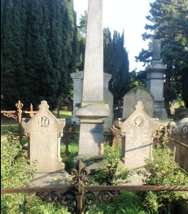Ref: B/110 - **MAHAFFY**

*Obelisk:* Erected by Trustees, Masters, and pupils of Lurgan College to JOHN GEORGE MAHAFFY, born 23rd June 1864, died 22nd April 1884. His school career was brilliant, his character sweet and gentle, his piety sincere. On his deathbed he murmured his favourite text *“I know that my Redeemer liveth, In my flesh I shall see God.”*

*Left side stone:* “To him to live was Christ.” In ever loving memory of HENRY MAHAFFY, Solicitor of Belfast. Born in Lurgan, June 27th 1856, fell asleep September 18th 1890. *“They that turn many to righteousness shall shine as the stars for ever and ever.”* Erected by his widow

*Right side stone:* In loving memory of MARY ELIZABETH MAHAFFY, daughter of JOHN B. and HENRIETTA MAHAFFY, who died 18th June 1879, aged 17 years and of the above named JOHN BAPTIST MAHAFFY, born 16th March 1819, died 27th April 1901, and of the above named HENRIETTA MAHAFFY who died 22nd August 1903, aged 78 years, and of HENRIETTA ANN MAHAFFY, daughter of the above named JOHN B. MAHAFFY, died 28th November 1920.

Ref: B/111 – **HETHERINGTON** (Unmarked)

Ref: B/112 – **THOMPSON/UPRICHARD** (Unmarked)

Ref: B/113 - **MAHAFFY** (Unmarked)

Ref: B/114 – 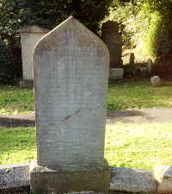**MOFFETT**

Erected by THOMAS MOFFETT in memory of his beloved wife ELIZA who departed this life on 28th February 1877, aged 46 years; also his son ROBERT, aged 5 years, and his infant daughter MARY ALICE. Also his son JOSEPH MOFFETT, who departed this life 29th June 1877, aged 18 years; also his eldest son WILLIAM MOFFETT, died 30th March 1899; Also the above named THOMAS MOFFETT who departed this life 19th October 1916. Also their son, EDWARD R. MOFFETT, beloved husband of SIDNEY MOFFETT, who departed this life 20th September 1941. Also their daughter ALICE MOFFETT who departed this life 26th February 1936 aged 70 years. CATHERINE, beloved wife of TOMAS MOFFETT, who departed this life 30th November 1948, aged 72 years. SIDNEY, beloved wife of above named EDWARD R. MOFFETT, who departed this life 2nd December 1890.

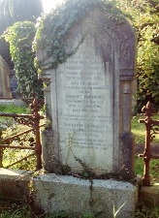Ref: B/115 - **MAHAFFY**

Sacred to the memory of SARAH GILBERT, for 54 years the devoted wife of WILLIAM MAHAFFY. She changed mortality for life 29th October 1884, aged 74 years. Here also rests the remains of her son, ROBERT MAHAFFY, who departed this life 21st October 1891, aged 48 years. He died as he lived from boyhood in firm trust on the Rock of Ages. WILLIAM MAHAFFY fell asleep 22nd February 1894, aged 84 years. Christ drew him in life and to old age kept him in the love and service of God.

Ref: B/116 – **MAHAFFY** (Unmarked)

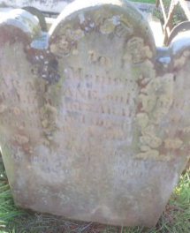Ref: B/117 – **NEALE**

Erected to the memory of SARAH JANE, only child of WILLIAM and SARAH NEALE, who departed this life the 5th March 1862, aged 14 years. *“Not lost but gone before.”*

Also the above WILLIAM NEALE who died on the 2nd April 1875, aged 74 years.

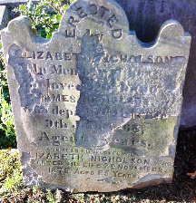Ref: B/118 - **NICHOLSON**

Erected by ELIZABETH NICHOLSON in memory of her beloved husband JAMES NICHOLSON who departed this life 9th J___ 1863, aged ?? years.

Also his beloved wife ELIZABETH NICHOLSON who departed this life 29 November 1875, aged 65 years

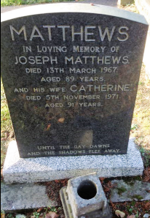Ref: B/119 – **MATTHEWS**

MATTHEWS In loving memory of JOSEPH MATTHEWS, died 13th March 1967, aged 89 years, and his wife CATHERINE, died 5th November 1971, aged 91 years.

*“Until the day dawns and the shadows flee away.”*

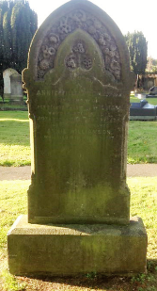Ref: B/120 – **WILLIAMSON**

Erected by ANNIE WILLIAMSON, Lurgan, in memory of her beloved husband WILLIAM who departed this life 20th March 1889, aged 50 years

Also the above named ANNIE WILLIAMSON who died 4th August 1917.

*“With Christ which is far better.”*

Ref: B/121 – Vacant

Ref: B/122 – **MEGAN**

Interment 7th February 1938

Ref: B/123 – **BLACK** (Unmarked)

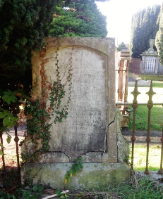Ref: B/124 – **ARMSTRONG**

Erected by admiring friends to the memory of the late REV. JOHN ARMSTRONG, Wesleyan Minister, born 1788, died 1st August 1875.

*For sixty years he discharged the duties of his Sacred Office with zeal and fidelity, barely if ever surpassed. Though dead, yet he speaketh.*

Also his daughter (second) MARGARET ARMSTRONG who died 31st December 1875, aged 48 years.

Also his widow ELLEN ARMSTRONG who departed this life 19th March 1876 aged 75 years.

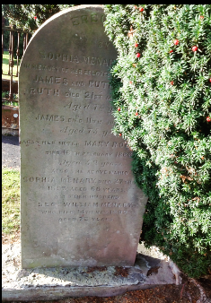Ref: B/125 – **MENARY/YOUNG**

Erected by SOPHIA MENARY in memory of her beloved ---------- JAMES and RUTH. RUTH died 21st M--- ---- Aged 74 years. James died 11th --- ---- Aged 75 years. Also her sister MARY RO—who died --------------- Aged 66 years. Also the above named SOPHIA MENARY who died 27th ------ ---- Aed 68? Years. Also WILLIAM MENARY who died -- ------- ---- Aged 70? years

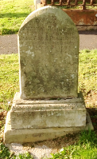Ref: B/126 – **ROBINSON**

Erected by FRANCIS ROBINSON in memory of his wife JANE ANNE ROBINSON who died 15th February 1881 aged 28 years.

Ref: B/127 – **KELLY** (Unmarked)

Ref: B/128 – Vacant

Ref. B/129 – **McCAULEY**

*(Note: Headstone no longer in position, 2015. Inscription from 1987 survey notes).*

In loving memory of WILLIAM R. McCAULEY who died 10th September 1930 aged 78 years.

Also his six children who died in infancy, also his wife.

Ref: B/130 – Vacant

Ref: B/131 - **ARCHER**

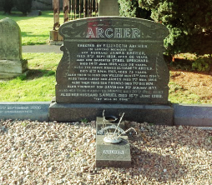  
Erected by ELIZABETH ARCHER in loving memory of her husband JAMES ARCHER died 11th September 1936, aged 69 years. Also her daughter ETHEL UPRICHARD died 14th June 1939, aged 38 years. Also the above named ELIZABETH ARCHER died 12th April 1953 aged 73 years Also their second son WILLIAM died 13th April 1954 Also their eldest son JAMES died 7th November 1954 Also their youngest son DAVID died 3rd January 1977; Also her third daughter MINNIE died 20th December 1987; Also her husband SAMUEL died 16th June 1988. *“Thy will be done.”*

*On surround (left): ---------- ----------------* 20th September 2006 Mother and Grandmother

Ref: B/132 – Vacant

Ref: B/133 – Vacant

Ref: B/133 – **REID**

Interments 25/03/1934; 18/02/1936; 02/07/1936;

Ref: B/134 – Vacant

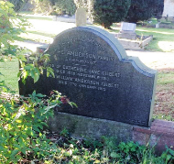Ref: B/135 – **ANDERSON**

In loving memory of the ANDERSON FAMILY, Lawnmount.

Also CATHERINE JANE GILBERT, died 19th September 1913 and WILLIAM ANDERSON GILBERT, died 17th January 1915

Ref: B/136 – Vacant

Ref: B/137 – Unknown

Ref: B/138 – **HOWELL**

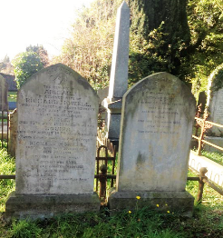*Left stone*: Sacred to the memory of ABIGAIL, the beloved wife of RICHARD HOWELL, who fell asleep in Jesus 13th October 1881, aged 31years; also to his daughters ALICE, died 18th July 1881, aged 5 years; LOUISA, died 8th August 1879, aged 11 months. *“With Christ which is far better.”*

RICHARD HOWELL entered into rest 14th February 1890, aged 45 years. *“Tis but a little while.”*

Also his wife ANNA, who died 25th December 1922, aged 78 years. *“Until the dawn and the shadows flee away.”*

*Right stone:*  Erected to the memory of RICHARD HOWELL who died 26th December 1889, aged 88 years. Also his beloved wife ALICE who died 15th March 1892, aged 70 years. *“Forever in the Lord.”*

Ref: B/139 – **Vacant**

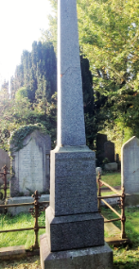Ref: B/140 – **NASSAU BRENNAN**

WILLIAM H. NASSAU BRENNAN of Lurgan, died 19th July 1885, aged 58 years.

This memorial is erected by a few friends in grateful recognition of his zealous services in the Throne of this Realm and also to mark their sincere sorrow at the loss of an amiable friend and erudite companion.

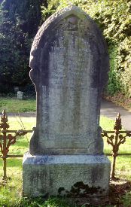Ref: B/141 – **GORMAN**

In loving memory of THOMAS GORMAN, who fell asleep in Jesus, June 10th 1886. Erected by his wife ANN GORMAN.

Also the above named ANN GORMAN who died June 1st 1911 in her 102nd year.

*“I am the Resurrection and the life, saith the Lord, and whosoever liveth and believeth in Me shall never die.” (John X1 25)*

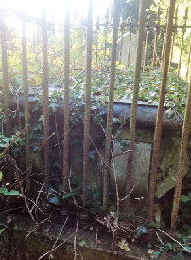Ref: A/142 – **BURKE**

Sacred to the memory of WILLIAM BURKE who departed this life on the 12th November 1855 and ANN, his beloved wife who died 15th December 1847

Also his nephew, WILLIAM BURKE MORRIS, died 11th April 1865 and JANE REID MORRIS, niece of the above WILLIAM BURKE, who died 19th August 1883, aged 80 years.

*“Resting till the day break and the shadows flee away.”*

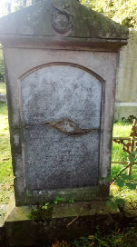Ref: B/143 – **MAY**

*(Note: In 1987 this stone was lying face down on the plot. It has since been raised but due to the considerable damage a lot is illegible).*

Erected by GEORGE MAY in memory of his beloved wife SARAH JANE

(Other legible names include: DAVID, JOSIAH and GEORGE).

Ref: B/144 –**UPRICHARD**

Note: During the 1987 survey the base of this headstone was still standing although there were no names on what was left of the stone. It did bear the quotation*:* ***“*** *Blessed are the dead which die in the Lord. Yea, saith the Spirit, that they may rest from their labours; and their works do follow them”.*

Ref: B/145 – **Vacant**

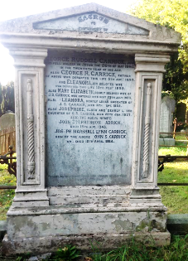Ref: B/146 – **CARRICK**

Sacred to the memory of GEORGE RUDDELL CARRICK who fell asleep in Jesus 26th May 1880 in the twentieth year of his age. Also GEORGE R, CARRICK, father of the above, who departed this life 5th August,1893 and ELEANORA, his beloved wife, who departed this life 15th February 1899. Also MARY ELIZABETH dearly beloved wife of J. S. CARRICK who entered into rest 28th July 1903. Also ELEANORA dearly loved daughter of J. S. CARRICK, died 4th September 1932. Also JOSEPHINE, elder and loved daughter of G. R. CARRICK died 25th January 1937. Also the above named JOHN STEPHENSON CARRICK, died 19th August 1943. JOSEPH MARSHALL LYNN CARRICK, son of the above JOHN S. CARRICK, who died 19th April 1964. *“They also which sleep in Jesus shall God bring with him.”*

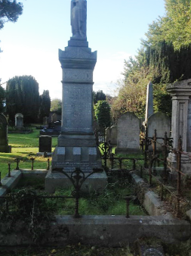Ref: B/147 – **SCOTT**

This monument is erected by the friends of J. M. JOHNSON SCOTT M.D., F.R.M. and C.S.L., in the Lurgan neighbourhood, who from an intimate knowledge of his worth place it here as a sincere tribute to his memory, his professional talents and his exemplary benevolence as a Physician. Died 30th November 1885*. “The merciful shall obtain mercy.”*

Also JEANIE, the dearly beloved wife of DR. W. MACARCAR SCOTT, D.M.O. of Liverpool who departed this life at Rhos-on-Sea in Wales on March 15th 1925, aged 35 years.

*Left face:* In loving remembrance of ELIZABETH JOSEPHINE, younger daughter of the late JOSEPH IRWIN of Millpark, Co. Down, and wife of the late JAMES CARTER of Belfast and the late J. M. JOHNSON SCOTT M.D., M.C.H., M.A.O. of Lurgan, who departed this life in the fullness of years on 12th October 1937. Esteemed and beloved by all. She lived for others not for herself. “*Blessed are the pure in heart for they shall see God.”* Matt. 5.8Also DR. W. MACARCAR SCOTT D.M.O. of Liverpool who departed this life 11th January 1940, aged 64 years. He passed not by them that were sick.

Ref: B/148 – Unknown

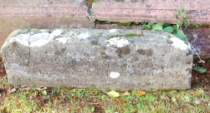Ref: B/149 – FLEMMING

Here lies the body of JOSEPH FLEMMING who departed this life 14th November 1799

Ref: B/150 – Vacant

Ref: B/151 – **MULHOLLAND** (Unmarked)

Ref: B/152 – **McCAPPIN** (Unmarked)

Interment 07/02/1978

Ref: B/153 – Vacant

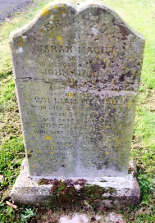Ref: B/154 – **MAGILL**

Erected by SARAH MAGILL of Lurgan in memory of her son JOHN MAGILL who died 21st January 1882, aged 27 years Also her husband WILLIAM MAGILL who died 20th January 1883 aged 55 years. Also of her son JOSEPH MAGILL who died 12th April 1886, aged 18 years Also her son WILLIAM MAGILL who died 16th June 1889, aged 30 years

Ref: B/155 – Unknown

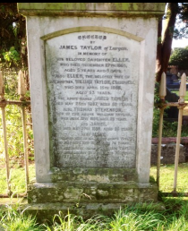Ref: B/156 – **TAYLOR**

Erected by JAMES TAYLOR of Lurgan in memory of his beloved daughter ELLEN who died December 27th 1865, aged 5 years and 5 days. Also Ellen, the beloved wife of his brother WILLIAM TAYLOR, Clanrolla, who died April 15th 1886, aged 53 years. The above named JAMES TAYLOR, died May 26th 1887, aged 58 years. Also THOMAS STEVENSON, son of the above WILLIAM TAYLOR, died June 18th 1896, aged 26 years and JAMES who died May 27th 1899, aged 26 years. Also the above named WILLIAM TAYLOR who died August 12th 1910, aged 79 years. Also MARGARET TAYLOR, who died 14th February 1921, aged 52 years.

*Small side stone reads*: MARY TAYLOR died 5th January 1951.

Ref: B/157 – **MAGEE**

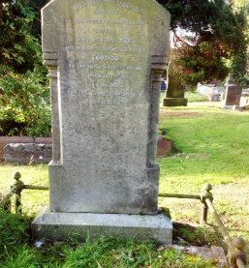The REV. WILLIAM MAGEE, Minister of the Presbyterian Church, Lurgan, died 9th July 1800.

His widow bequeathed about £60,000 to the Irish Presbyterian Church, including £20,000 for the establishment of a college.

Ref: B/158 – **GEDDIS** (Unmarked)

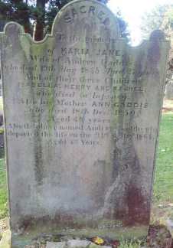 Ref: B/159 – **GADDIS**

Sacred to the memory of MARIA JANE, wife of ANDREW GADDIS, who died 19th May 1855, aged 27 years, and of their three children, ISABELLA, HENRY and RACHEL who died in infancy. Also his mother, ANN GADDIS, who died 18th December 1850. Also the above named ANDREW GADDIS who departed this life 21st of May 1864, aged 43 years

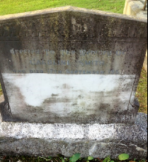Ref: B/160 - **SMITH**

Erected to the memory of CAROLINE SMITH, who died 17th September 1950

Ref: B/161 – **JAMISON**

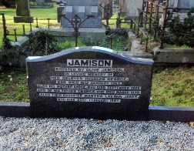 Erected by OLIVE JAMISON in loving memory of her loving husband GEORGE who died 16th January 1963. Also his mother ANNIE who died September 1925 and of his father GEORGE who died in March 1935. Also MARTHA LAVINIA JONES, daughter of the above named GEORGE and ANNIE died February 1987

Ref: B/162 – **EVANS**  (Unmarked)

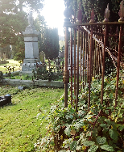Ref: B/163 – **HALL**

Plot, enclosed by high railings (rusted), was overgrown during both surveys and has been for a very long time. There are no visible markings but could possibly contain a vault.

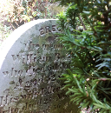Ref: B/164 - **BELSHAW**

Erected to the memory of WILLIAM BELSHAW who died 6th July 1859 aged 52 years. His wife ELLEN BELSHAW who died 25th November 1843 aged 56 years. Their daughter MARY BELSHAW, died 27th February 1845, aged 22 years

*(2015 – Stone almost hidden by vegetation)*

Ref: B/165 – Unknown

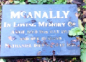Ref: B/166 - **McANALLY**

In loving memory of ANNIE McANALLY died 28th July 1957

Also her husband NATHANIEL died

Ref: B/167 – **ELLIOTT** (Unmarked)

Ref: B/168 – **GREGSON** (Unmarked)

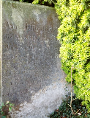Ref: B/169 – **ELLIS**

ANNE ELLIS died July 179?, aged 71 years; ROBERT ELLIS died May 1811, aged 54 years; JAMES ELLIS died July 1817, aged 48 years; MARGARET ELLIS, mother of ROBERT and JAMES, died December 1865, aged 8? years; LUCY, widow of the above named JAMES, died July 1864 aged 80 years; ROBERT ELLIS died 18th September 1877, aged 66 years; ELIZA ELLIS, wife of the above ROBERT ELLIS died 25th May 1881, aged 71 years

*(Stone is very badly weathered and obscured by vegetation – 2015)*

Ref: B/170 – Unknown

Ref: B/171 –**BELL/PRUDENCE** (Unmarked)

Ref: B/172 – Unknown

Ref: B/173 – **ENGLISH** (Unmarked)

Interment 27/02/1934

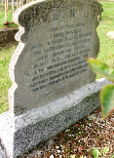Ref: B/174 – **McMAHON**

Erected by their family in loving memory of our dear father WILLIAM McMAHON, who died 28th September 1914 aged 56 years. Also our dear mother MARY JANE who died 17th November 1945 aged 84 years. Also their daughter MARGARET ANN, who died 10th June 1976 aged 84 years. Also their daughter MARTHA McMAHON who died 19th May 1978 aged 78 years,

*“Until the day dawns.”*

Ref: B/175 - **ALLEN**

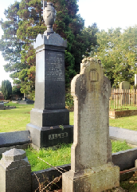Erected by his wife and children in loving memory of JOSEPH ALLEN who died 20th June 1890, aged 53 years

CATHERINE ALLEN born 10th December 1844, died 10th December 1894

JOSEPH ALLEN, Third Australian Imperial Forces, killed at Lous, 28th November 1916 by a German mine explosion while listening in a mine gallery. Buried in Military Cemetery, Hersin. *“For they shall be called Sons of God.”*

WILLIAM ALLEN, died 16th October 1926, aged 83 years.

Ref: B/176 – Vacant

Ref: B/177 – Unknown

Ref: B/178 – Unknown

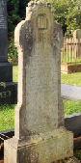Ref: B/179 – **ARCHER**

In loving memory of JOSEPH ARCHER, died 24th September 1922, aged 60 years. His wife MARY, died February 1908, aged 65 years. Their son JOHN died 1893. Also their daughter, MAGGIE, died 1920. Also children died in infancy. Also ANNIE ARCHER died 4th September 1931.

Ref: B/180 – **UPRICHARD**

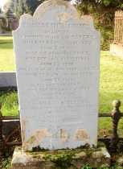Erected by THOMAS UPRICHARD of Lurgan in memory of his son ROBERT who died 24th October 1879, aged 2 years. Also his daughter ANNIE who died 12th August 1885, aged 23 years. Also his daughter LIZZIE who died 25th January 1889, aged 20years. Also his son JOHN who died 16th August 1892, aged 26 years. Also the above named THOMAS UPRICHARD who departed this life 21st December 1907, aged 75 years. Also MARIA, the beloved wife of the above THOMAS UPRICHARD who died 19th April 1911, aged 75 years. *“Thy will be done.”*

Ref: B/181 – Vacant

Ref: B/182 – **SERPLIS** (Unmarked)

Ref: B/183 – Vacant

Ref: B/184 – **BROWN** (Unmarked)

Ref: B/185 – Unknown

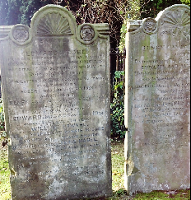Ref: B/186 – **McCABE**

*Left stone:* Erected by EDWARD MCCABE of Lurgan, in memory of his revered parents EDWARD GAMBLE and JANE McCABE who departed this life, the former May 15th 1858 aged 57 years, the latter May 25th 1858, aged 46 years; Also their sons, ROBERT who died July 4th 1858 aged 17 years, HENRY GAMBLE who died May 22nd 1867 aged 21 years. Also the above named EDWARD McCABE who died 19th August 1881, aged 44 years. WILLIAM EDWARD, son of STEPHEN and MINNIE McCABE, died 19th September 1891, aged 6 months; also their daughter ANNIE MABEL died 18th June 1920, aged 26 years; also their father STEPHEN McCABE who died 28th November 1927 aged 79 years; also their mother MINNIE McCABE, died 11th April 1934, aged 76 years.

*Right stone*: Erected by HENRY GAMBLE McCABE of Lurgan in memory of his revered parents EDWARD and JANE McCABE, the former departed this life 4th June 1833 in the 68th year of his age, and the latter on the 30th of May 1845 aged 91 years*. “Blessed are the dead which die in the Lord.”*

Also his son JOSEPH McCABE, died 14th December 1851, aged 4 years; also his son WILLIAM, died 10th July 1856, aged 17 years. SUSAN McCABE died 28th November 1953, aged 62 years. STEPHEN McCABE, died 25th July 1965, aged 74 years. MARY GIFFIN died 31st October 1965, aged 77 years.

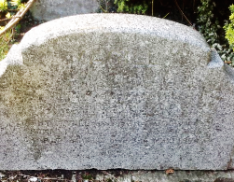Ref: B/187 – **MAGILL**

In loving memory of ELLEN, beloved wife of CHARLES MAGILL died 7th February 1950; also his son ALBERT REGINALD died 27th July 1942; also his daughter ELLEN died in infancy. HARRY MAGILL died 17th February 1894; THOMAS MAGILL died 21st March 1969; CHARLES MAGILL died 9th May 1959. *“Jesus in the midst.”* HARRY LESLIE MAGILL, grandson, died 26th July 1944.

*(Note: This grave has been vandalised since 1987 and the stone broken. Photo taken 2015 is all that remains).*

Ref: B/188 – Vacant

Ref: B/189 – **WEBB** (Unmarked)

Ref: B/190 – **NAUGHAN** (Unmarked)

Ref: B/191 – **BENT**

ELIZABETH BENT, daughter of ROBERT BENT of Harpenden, Herts, died 26th October 1853, aged 79. *“Believe on the Lord Jesus Christ and thou shalt be saved.” (Acts 16)*

Ref: B/192 – **LONSDALE** (Unmarked)

Interment 07/02/1972

Ref: B/193 – **CUNNINGHAM** (Unmarked)

Ref: B/194 – **GRACEY**

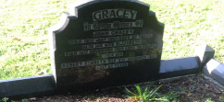In loving memory of JOHN GRACEY, died 12th July 1961, aged 69 years. Also his wife ELIZABETH, died 14th November 1967, aged 74 years. Their son, ROBERT KENNETH died 8TH November 1992, aged 62 years

Ref: B/195 – Vacant

Ref: B/196 – **MAXWELL**

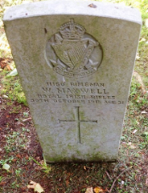11160 Rifleman W. MAXWELL, Royal Irish Rifles, 30thOctober 1918 aged 31 years.

Ref: B/197 – **TURKINGTON** (Unmarked)

Ref: B/198 – **MONROE** (Unmarked)

Ref: B/199 – Vacant

Ref: B/200 – **ANDERSON** (Unmarked)

Ref: B/201 – **ATKINS**

To the memory of HENRY ATKINS Esquire who died the 26th of October 1833, aged 68 years. *(Note tombstone missing 2015)*

Ref: B/202 – **WATTERS**

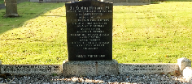In loving memory of JENNIE WATTERS died 28th January 1892; also JAMES WATTERS died 27th December 1?61; also WILLIAM JOHN WATTERS killed at Ypres 16th August 1917; also MAGGIE WATTERS died16th May 1922; also MINNIE WATTERS died 18th May 1923 aged 21 years; also her mother, ANNIE WATTERS died3rd February 1924 aged 55 years; their father WILLIAM died January 1938. Left side: DEREK WATTERS died 28th May 1942; SAMUEL WATTERS died 3rd September 1968. Right side: ISABELLA WATERS died 16 January 2006.

Ref: B/203 - Vacant

Ref: B/204 – **RUSSELL** (Unmarked)

Ref: B/205 – **METCALFE**

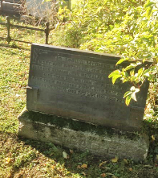In loving memory of

MARY ANN METCALFE, died 10th September 1887

Also her husbandJOHN METCALFE, died 11th August 1895

Also their son, WILLIAM JOHN, died 1911

Also their daughter, EMMA, died 26th September, 1947.

SARAH METCALFE died 22nd September 1951, aged 78 years.

Ref: B/206 - **NOBLE** (Unmarked)

Ref: B/207 – Vacant

Ref: B/208 – **FOLLIS**

Erected by FRANCIS FOLLIS to the memory of his mother, JANE ELIZABETH JENNINGS FOLLIS, died 1910, also his father GEORGE FOLLIS, died 1907 and his brothers and sisters.

Ref: B/209 – Vacant

Ref: B/210 – **PENTLAND** (Unmarked)

Ref: B/211 – Unknown

Ref: B/212 – **CAULFIELD** (Unmarked)

Ref: B/213 – Vacant

Ref: B/214 – **BROWN**

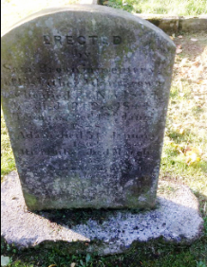

Erected by SAM BROWN in memory of his father ADAM BROWN who died 2nd November 1844; JOE, died 19th December 1844; THOMAS, died 12th January 1848; ADAM, died 31st January 1868. SARAH BROWN, died 11th January 1873, aged 37 years; ROBERT BROWN died 12th December 1875 in the 14th year of his age.

Ref: B/215 – **McMURRAY** (Unmarked)

Ref: B/216 – Unknown

Ref: B/217 – **LAMIE** (Unmarked)

Ref: B/218 – **NESBITT** (Unmarked)

Ref: B/219 – Vacant

Ref: B/220 – **MITCHELL** (Unmarked)

Ref: B/221 – **RUDDELL** (Unmarked)

Ref: B/222 – Vacant

Ref: B/223 – **LITTLE**

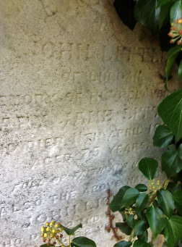Erected by JOHN LITTLE of Lurgan in memory of his beloved wife, MARY JANE LITTLE, who died 11th April 1884, aged 75. *“Full of faith and hope.”*

Also the above named JOHN LITTLE, who died 22nd February 1891, aged 82 years.

Ref: B/224 – **BROWNLEE**

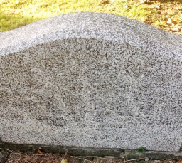

In loving memory of ELIZABETH MARIA, died 16th October 1931 Her husband WILLIAM HENRY MATHERS, died 6th September 1962. *“The Lord is my Shepherd.”*

Ref: B/225 – **LEATHEM** (Unmarked)

Ref: B/226 – **EVANS** (Unmarked)

Ref: B/227 – **TROTTER** (Unmarked)

Ref: B/228 – **LAVERY** (Unmarked)

Ref: B/229 – **HOBBS** (Unmarked)

Ref: B/230 - Vacant

Ref: B/231 – **WHITE/THOMPSON** (Unmarked)

Ref: B/232 – Vacant

Ref: B/233 **BATTERSBY** (Unmarked)

Ref: B/234 - Vacant

Ref: B/235 – **BROWN** (Unmarked)

Ref: B/236 – **McCOLLUM**

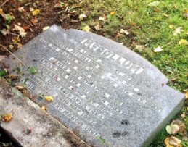In loving memory of ROBERT McCOLLUM, died 24th May 1952 Also his beloved wife JANE, died 28th November 1942, Also their children, JAMES, died 15th April 1895, ROBERT, died 10th May 1904, EMILY, died 19th November 1903, JANE, died 14th April 1964, ANNE, died 26th May 1967, ADELAIDE, died 3rd March 1961

Ref: B/237 – **IRWIN** (Unmarked)

Ref: B/238 – **KERR** (Unmarked)

Ref: B/239 – **DAVIS** (Unmarked)

Ref: B/240 – **BURKE** (Unmarked)

Ref: B/241 – Vacant

Ref: B/242 – **CUNNINGHAM**

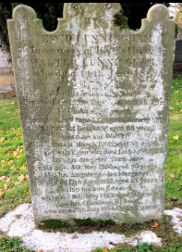

Erected by EDWARD CUNNINGHAM in memory of his father WALTER CUNNINGHAM, who died 14th January 1869, aged 78 years; Also his beloved mother ELIZABETH CUNNINGHAM, died 26th April 1874, aged 86 years; Also the above named EDWARD CUNNINGHAM, who died 1st December 1891, aged 68 years; Also his son WALTER, who died 1st March 1903, aged 30 years; Also his wife ELLEN, who died 13th April 1907; Also his daughter ELIZA JANE, who died 4th May 1956, aged 86 years; Also his daughter in law MARGARET, who died 17th April 1952, aged 83 years; Also his son EDWARD, who died 16th May 1953, aged 80 years; Also his grandson ROBERT, who died 27th July 1954, aged 46 years.

Ref: B/243 – Vacant

Ref: B/244 – **MULHOLLAND**

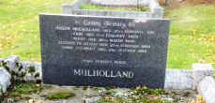In loving memory of JOSEPH MULHOLLAND, died 26th February 1916; JOHN MULHOLLAND, died 10th February 1929; MARY, died 29th March 1946; ELIZABETH (ELIZA), died 25th February 1984 “Peace Perfect Peace.”

Ref: B/245 – **MORRISON** (Unmarked)

Ref: B/246 – **GLENDINNING**

In memory of JOHN GLENDINNING, died 13th March 1871, aged 76 years; his wife ANN, died 22nd June 1867, aged 82 years; ELLEN, wife of JAMES GLENDINNING, died 16th August 1870, aged 42 years; their daughter MAGGIE, died 25th May 1878, aged 5 years and 10 months. Also the above named JAMES GLENDINNING, died 1st April 1893, aged 70 years; their son, JAMES HERMON GLENDINNING, died 8th December 1926, aged 68 years; their daughter, MARY GLENDINNING, died 14th August 1828, aged 73 years*. “Blessed are the pure in heart.”*

Ref: B/247 – **BLACK**

In loving memory of our parents SAMUEL, died 20th June 1929, ANNIE, died 8th October 1970.

*“At Rest.”*

Ref: B/248 – Vacant

Ref: B/249 – Vacant

Ref: B/250 – **BEST** (Unmarked)

Ref: B/251 – **FLEMMING** (Unmarked)

Ref: B/252 – Vacant

Ref: B/253 – **CROZIER** (Unmarked)

Ref: B/254 – **GRAHAM** (Unmarked)

Ref: B/255 – **JOHNSON** (Unmarked)

Ref: B/256 – **FLEMMING** (Unmarked)

Ref: B/257 – **GREER**

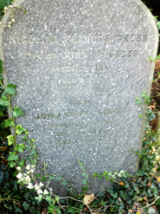NICOLINA FRANCES GREER, wife of JOHN W. GREER, aged 55 years fell asleep 7th April 1880, Also JOHN WAITE GREER, Woodville, Lurgan, 20th February 1885 aged 79 years

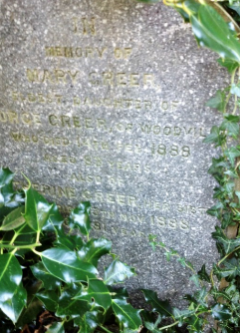In memory of MARY GREER, eldest daughter of GEORGE GREER of Woodville, who died 14th February 1888, aged 83 years

Also CATHERINE GREER, her sister, who died 13th November 1888, aged 81 years

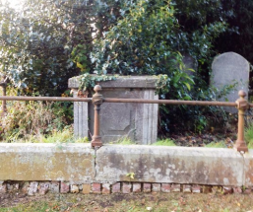Here lieth the body of GEORGE GREER of Woodville, who departed this life the 11th day of October 1856, aged 72

Also of ANN, his wife, who died the 31st day of August 1864, aged 63

SARAH MILDRED OLDFIELD -----------------, also GEORGE GREER, Woodville, Lurgan, born 26th November 1849, died January 27th 1892’

In memory of his eldest son, LIEUT. A. GREER, West India Regt., born May 31st 1877, killed in action, August 7th 1900, near Kumassi.

Ref: B/258 Unknown

Ref: B/259 – **CARSON**

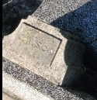This small memorial vase marked the grave in 1987. It was found close by in 2015, together with remains of smashed stone and surround of another grave.

Ref: B/260 Unknown

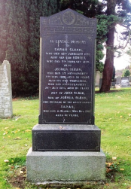Ref: B/261 – SLOAN

In memory of SARAH SLOAN, who died 18th February 1887

Also her son, ROBERT, who died 7th February 1879

Also JOSHUA SLOAN, who died at Moyraverty, 7th February 1866, aged 56 years; also his wife, THOMASINA, who died at Moyraverty, 28th July 1893, aged 80 years

Also JOHN SLOAN, son of JOSHUA SLOAN, and husband of the above named SARAH, who died in Belfast, 20th November 1912, aged 80 years

Ref: B/262 – McNEICE

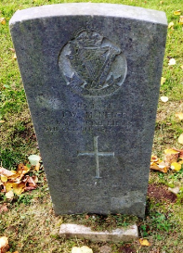

5115 L.CPL. J. W. McNEICE,

Royal Irish Rifles,

5th October 1915

Aged 22 years

*“Quis Separabit”*

Ref: B/263 – **THOMPSON** (Unmarked)

Ref: B/264 – **CROZIER**

Ref: C/265 – **HARLAND/ANDERSON**

Ref: C/266 – **SULLIVAN**

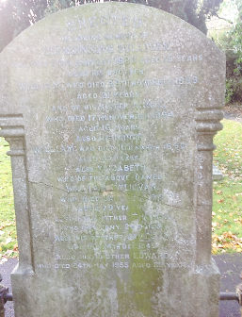Erected in loving memory of GLENDENNING SULLIVAN, who died 20th January 1886, aged 19 years. Also his brother WILLIAM, who died 29th November 1889, aged 21 years and of his sister ANNIE, who died17th November 1894, aged 16 years. Also his father WILLIAM, who died 11th March 1897, aged 65 years. Also ELIZABETH, wife of the above named WILLIAM SULLIVAN, who died 4th January 1919, aged 79 years. Also his brother THOMAS, who died 20th January 1930. Also his brother JAMES, who died 4th December 1943. Also his brother EDWARD who died 24th May 1955 aged 82 years.

Ref: C/267 – HALL (Unmarked)

Ref: C/268 – Vacant

Ref: C/269 – McFALL (Unmarked)

Ref: C/270 – HOBBS/STEWART (Unmarked)

Ref: C/271 – **UPRICHARD**

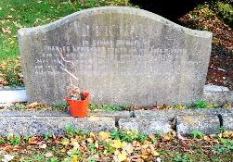

In loving memory of CHARLES UPRICHARD, died 7th January 1907, aged 77 years and his wife MARTHA, died 20th November 1885, aged 59 years. Also their daughter MATILDA, died 2nd November 1902, aged 32 years and their son WILLIAM JAMES, died 23rd August 1932, aged 59 years. Also their daughter ELLEN JANE, died 21st July 1954, aged 87 years. *(Note: This gravestone is facing opposite to all the others which face the rising sun.)*

Ref: C/272 – Vacant

Ref: C/273 – **THOMPSON** (Unmarked)

Ref: C/274 – BENNETT

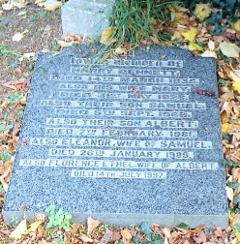

In loving memory of HARRY BENNETT died 14th March 1935. Also his wife MARY, died 31st May 1926. Also their son SAMUEL, died 5th September 1968. Also their son ALBERT, died 7th February 1981. Also ELEANOR, wife of SAMUEL, died 26th January 1985. Also FLORENCE ETHEL, wife of ALBERT, died 14th July 1997

Ref: C/275 – Vacant

Ref: C/276 – Vacant

Ref: C/277 – **BRIGGS** (Unmarked)

Ref: C/278 – **MARTIN** (Unmarked)

Ref: C/279 – (a) **HUMPHRIES** (Unmarked)

Ref: C/279 - (b) **DOUGLAS**

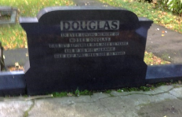In loving memory of MOSES DOUGLAS, died 12th September 1934, aged 65 years and of his wife JEANNIE, died 24th April 1965, aged 93 years.

*A small memorial vase which was on the grave in 1987 but missing in 2015 was inscribed* THOMAS ANDREWS, died 28th February 1959.

Ref: C/280 – **WATSON** (Unmarked)

Ref: C/281 – Vacant

Ref: C/282 – **SANDS/McKNIGHT** (Unmarked)

Ref: C/283 – **SCOTT** (Unmarked)

Ref: C/284 – **BUNTING** (Unmarked)

Ref: C/285 – **EMERSON** (Unmarked)

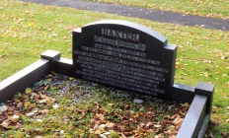Ref: C/286 – **BAXTER**

In loving memory of SAMUEL, died 6th March 1941. His wife SARAH JANE, died 18th October 1951

Their son, NORMAN GEORGE (Canada) died 8th July 1972. Their daughter, CHRISTINE, died 13th August 1975. Their daughter, ELIZABETH JANE, died 1st February 1985. Their son, SAMUEL, (Canada) died 12th August 1985. Their daughter, MARION, died 10th December 1985. Their son, WILLIAM, (Australia) died 22nd September 1987. Their son, CECIL ARNOLD, died 21st July 1994.

Ref: C/287 – **McDOWELL** (Unmarked)

Ref: C/288 – **BAXTER/REYNOLDS** (Unmarked)

Ref: C/289 – Vacant

Ref: C/290

Ref: C/291

Ref: C/292 Vacant

Ref: C/293 Vacant

Ref: C/294 – **ALLEN**

Interments: 15/02/1902; 31/12/1942; 18/07/1974

Ref: C/295 – **ALLEN** (Unmarked) Martin interred 23/11/74

Ref: C/296 – **WELLS** (Unmarked)

Ref: C/297 – **GLASS**

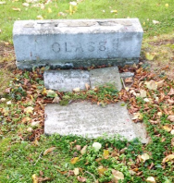

Erected by SAMUEL and MARGARET GLASS in loving memory of their dear son SAMUEL HENRY GLASS who died 15th August 1933, aged 6 years. Also their son THOMAS WILLIAM GLASS died 5th May 1941, aged 32 years. Also the above named SAMUEL GLASS who died 7th March 1950, aged 50 years. Also his beloved wife, MARGARET who died 7th April 1955, aged 71 years. *(Grave vandalised)*

Ref: C/298 – **KENNEDY**

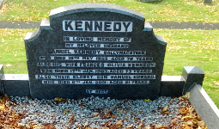In loving memory of my dear husband SAMUEL KENNEDY , Ballymacateer, who died 18th May 1955, aged 78 years. Also his wife, FRANCIS OLIVIA KENNEDY, who died 17th January 1969, aged 73 years.

Ref: C/299 – **MORROW**

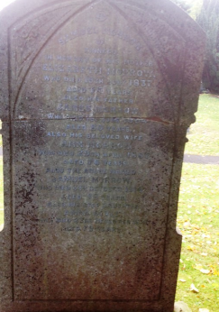

*First stone:* Erected by SAMUEL MORROW of Kinnego in loving memory of his mother ELIZABETH MORROW who died 15th July 1837, aged 60 years. Also his father JAMES MORROW who died 1st June 1864, aged 80 years. Also his beloved wife ANN MORROW who died 29th April 1887, aged 76 years. Also the above named SAMUEL MORROW who died 6th October 1914, aged 98 years. Also his stepdaughter ANNA DOYLE, who died 23rd December 1921, aged 79 years.

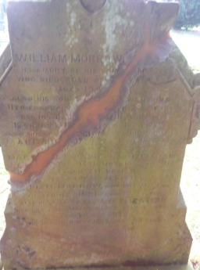

*Second stone:* Erected by WILLIAM MORROW of Clanrole in memory of his son HENRY who died 20th November 1873, aged 19 years. Also his son SAMUEL who died 11th February 1876, aged 23 years. Also his daughter ANN who died 17th June 1877, aged 13 years. Also his son WILLIAM and daughter MARGARET who died in infancy. Also his beloved daughter MARGARET JANE who departed this life on 26th November 1880 aged 20 years. Also the above named WILLIAM MORROW who died the 10th day of January 1891, aged 73 years, Also his beloved daughter ELIZABETH who died 23rd December 1900 aged 48 years. Also his wife RUTH who died 20th July 1903 aged 80 years.

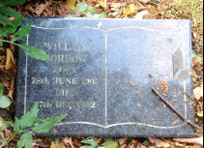*Small tablet lying on grave:*

WILLIAM MORROW

Born 28th June 1907

Died 27th December 1982

Ref: C/300 Unknown

Ref: C/301 – **CARSON** (Unmarked)

Ref: C/302 Unknown

Ref: C/303 – **McILWAINE** (Unmarked) S. McIlwaine

Ref: C/304 Vacant

Ref: C/305 – **TURKINGTON**  (Unmarked)

Ref: C/306 – **RUSSELL** (Unmarked)

Ref: C/307 Vacant

Ref: C/308 – **QUAIL/MAGILL** (Unmarked)

Ref: C/309 Vacant

Ref: C/311 – **SEWELL** (Unmarked)

Ref: C/312 Vacant

Ref: C/313 – **KING/PATTERSON** (Unmarked)

Ref: C/314 – **HAMILTON** (Unmarked)

Ref: C/315 Vacant

Ref: C/316 – **WILSON**  (Unmarked)

Ref: C/317 –**WILSON** (Unmarked)

Ref: C/318 – **BROWN** (Unmarked)

Ref: C/319 – **MATTHEWS**

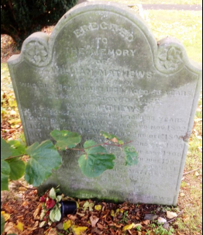Erected to the memory of WILLIAM MATTHEWS of Tagnavin who died 8th August 1839 aged 56 years, Also his beloved wife ANN MATTHEWS who died 24th August 1871 aged 88 years. JAMES MATTHEWS died 3rd November 1892. JOHN MATTHEWS died 22nd December 1894. ROBERT MATTHEWS died 22nd December 1899. JANE MATTHEWS died 10th January 1900. WILLIE F. MATTHEWS died 28th June 1902. RACHEL MATTHEWS died 3rd July 1941, wife of the above JAMES MATTHEWS. Also JOHN MATTHEWS son of the above JAMES MATTHEWS who died 7th January 1945. SARAH, wife of the above JOHN MATTHEWS died 29th April 1946.

Ref: C/320 Vacant

Ref: C/321 Vacant

Ref: C/322 – **QUINN**

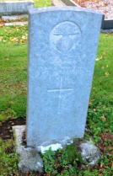Ref: C/333 – **IRWIN**

29440 L.CPL.

W. T. IRWIN

Royal Irish Fusiliers

16th May 1919

Aged 19

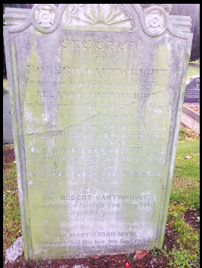Ref: C/324 – **MONROE/CARTWRIGHT**

Erected by ROBERT CARTWRIGHT in memory of his beloved mother ELEANOR CARTWRIGHT who departed this life 22nd of June 1852, aged 76 years. Also above named ROBERT who departed this life 10th of October 1868, aged 45 years. JOHN CARTWRIGHT who departed this life 28th March 187, aged 65 years. Also MARY SARAH CARTWRIGHT who departed this life 29th October 1871, aged 63 years. Also ROBERT CARTWRIGHT who departed this life 3rd May 1914, aged 67 years. MARY SARAH MONROE who departed this life 17th March 1933. Also MARY SARAH IRWIN who departed this life 9th September 1934. ROBERT died 18th February 19?? SAMUEL died 12th March 19??

Interments – 18/03/1933; 19/09/1934; 10/12/1936; 14/06/1932; 13/06/1964

Ref: C/325 – **NICHOLSON**  (Unmarked) Interment 30/09/1935

Ref: C/326 – **GIRVAN** (Unmarked)

Ref: C/327 Vacant

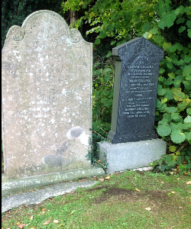Ref: C/328 – **COLLINS**

Left stone: Erected by WILLIAM COLLINS of Tagnavin in memory of his daughter, SARAH ANN COLLINS, who departed this life 1st May 1869, aged 8 years. Also his wife, RACHEL COLLINS, who departed this life 11th February 1870, aged 44 years and also his son, GORDON COLLINS, who departed this life 9th June 1880 aged 31 years.

Right stone: Erected by HANNAH COLLINS of Tagnevan in loving memory of her sister, DINAH COLLINS, who died 15th May 1906, aged 74 years; and of her brother, JOHN, who died 1st January 1911, aged 77 years. The above named HANNAH COLLINS, who died 2nd April 1915, aged 79 years.

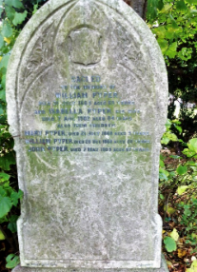Ref: C/329 – **PYPER**

Erected to the memory of WILLIAM PYPER, died 31st July 1883, aged 69 years and ISABELLA PYPER, his wife, died 7th August 1902, aged 84 years. Also their children MARY PYPER, died 21st July 1860 aged 9 years, WILLIAM PYPER died 26th December 1860 aged 20 years, and JOHN PYPER died 7th May 1909 aged 67 years

Ref: C/330 – **FUGARD** (Unmarked) - Interments 07/12/1935; 27/03/1940; 28/09/1962; 19/12/1979; 16/12/1981

Ref: C/331 – **BUNTING**

Erected by THOMAS BUNTING in loving memory of his beloved wife ANN who departed this life 16th September 1816.

Two memorial vases on grave 1988 inscribed: (1) JAMES BUNTING and (2) JOHN BUNTING.

Ref: C/332 – **McCORRY**

In remembrance of my dear husband HENRY McCORRY who died January 8th 1927. *“Forever with the Lord.”* Erected by his sorrowing wife and family.

*(Note: Stone about 24 inches high lying under tree beside path – broken - not found 2015).*

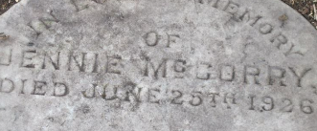*Second stone:* In loving memory of JENNIE McCORRY, died June 25th 1926. *“Till He come.”*

*(Stone not found 2015)*

Ref: C/333 Vacant

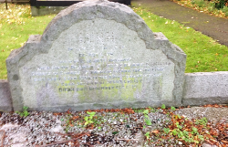Ref: C/334 – **LUNN**

In loving memory of GEORGE LUNN, his wife ELIZABETH and Family. Their son, the REVEREND JAMES STEWART LUNN, Curate in charge of Rathlin Island 1945-1950, died April 22nd 1950 in the 59th year of his age. A good Soldier of Jesus Christ. DINAH died December 4th 1975.

(Inscriptions on surround illegible).

Ref: C/335 – **CLARKE/DOYLE** (Unmarked)

Ref: C/336 – **HILL/SILCOCK**

A.HILL and RACHEL SILCOCK died 28/11/1932

Ref: C/337 – Unknown

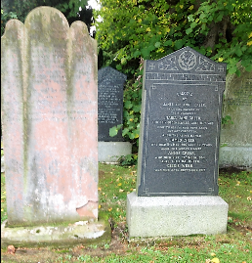Ref: C/338 – **GREER**

*Left stone:* Erected to the memory of WILLIAM HENRY GREER of Lurgan, who died 28th January 1873, aged 48 years. Also his daughter, MARIA JANE, who died 16th May 1878, aged 33 years. Also his beloved wife RACHEL, who died 28th February 1879, aged 54 years. “*Thy will be done*.” Also his son JOHN who died 6th October 1880, aged 29 years. Also his daughter MARGARET, who died 18th January 1893, aged 44 years.

*Right stone:* Erected by JAMES and ANNIE GREER in loving memory of their daughter, MARIA JANE GREER, died 28th December 1901, aged 16 years.  *“Gone to her Father’s home above. But not forgotten.”* Also the above named JAMES GREER, who died 5th May 1907, aged 52 years. Also the above named ANNIE GREER, who died 21st December 1934. Also their daughter, CISSIE WEBB, who died 27th September 1917.

Ref: C/339 – **LYNCH** (Unmarked)

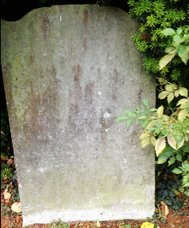Ref: C/340 - **WEBB**

FLOVER WEBB, Deperd ye life December 28th 1772 aged 61 years. Also his wife MARY WEBB, Deperd ye life November ye 7th 1774 aged 35. Also JACOB WEBB died 19th January 1916, aged 82 years, and his wife, ELIZABETH WEBB died 28th February 1918, aged 72 years. Also ELIZABETH DEWART died 15th September 1935 aged 86 years.

Ref: C/341 – **BROWN** (Unmarked)

Ref: C/342 – **GILBERT**

Here lyeth the body of JONATHAN and ANN GILBERT who departed this life in the year 1740. Also the body of JOHN TURNER who departed this life in the year 1790 aged one year and 5 months.

Ref: C/343 – **SETON** (Unmarked)

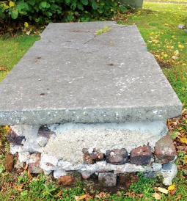Ref: C/344 - **GILBERT**

*“Remember Death”*

Sacred to the memory of ANN, wife of HENRY GILBERT of Lurgan, 25th January 1828 aged 60 years. Also HENRY GILBERT Jnr. Who died 27th October 1832 aged 43 years*. “The righteous shall ------------.”* HENRY GILBERT Snr. Who died in 1847 and his son JOHN died 29th April 1872.

Ref: C/345 – **HILL** (Unmarked)

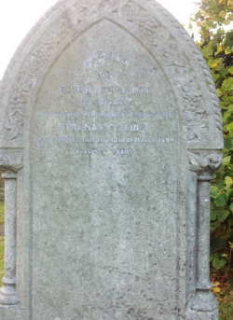Ref: C/346 – **COLLINS**

Erected by ROBERT COLLINS of Belfast in affectionate remembrance of his brother THOMAS COLLINS who departed this life 10th of March 1899 aged 26 years

Ref: C/347 Vacant

Ref: C/348 Vacant

Ref: C/349 – **MULHOLLAND** (Unmarked)

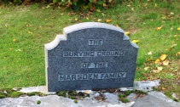Ref: C/350 – **MARSDEN**

The burial ground of the MRSDEN Family.

Ref: C/351 – **FITZSIMONS** (Unmarked)

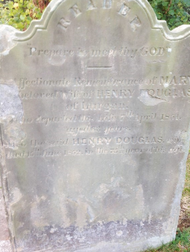Ref: C/352 – **DOUGLAS**

Reader “Prepare to meet thy God”

In affectionate remembrance of MARY, the beloved wife of HENRY DOUGLAS of Lurgan, who departed this life 7th April 1851 aged 63 years. Also the said HENRY DOUGLAS who died 15th June 1852 in the 75th year of his life.

Ref: D/354 – Vacant

Ref: D/355 – **NEWELL** (Unmarked)

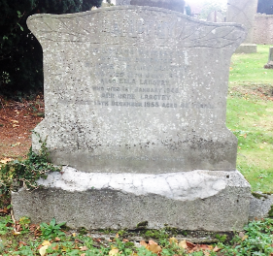Ref: D/356 – **LANGTRY**

In loving memory of my dear daughter ELIZABETH (LILY), who died 11th July 1937

Also ELLA LANGTRY, who died 1st January 1946

ANN JANE LANGTRY who died 15th December 1955, aged 92 years.

*“Safe in the arms of Jesus”*

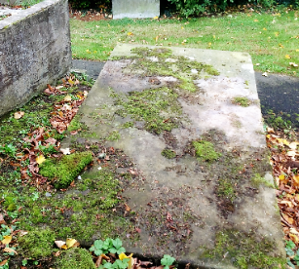Ref: D/357 – **HALL**

Here lies the body of JOSEPH HALL Snr. who departed this life 15th of July 1782 aged 82 years.

Also ELIZABETH, his wife, who departed this life 19th March 1787 aged 89 years.

JOHN HALL, son of THOS. HALL, departed this life the 1st May 1796 in the 19th year of his age.

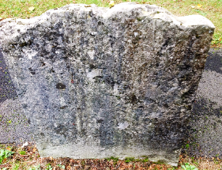Ref: D/358 – **CASTLES**

--------- who departed this life January 18th 1785 aged –

Interments: 11/04/1934; 12/11/1936; 09/09/1963; 20/11/1986

Ref: D/359 – **HEWITT** Interment: 22/12/1934 (Unmarked)

Ref: D/360 – **MADDEN** (Unmarked)

Ref: D/361 Vacant

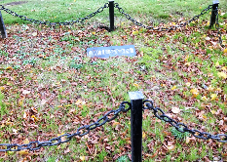Ref: D/362 – **WILSON**

WILSON

Ref: D/363 Vacant

Ref: D/364 - **THOMPSON** (Unmarked)

Ref: D/365 – **LINDSAY**

Ref: D/366 – **McWHINNEY**

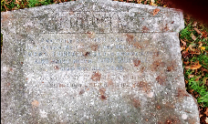Ref: D/367 – **BURRELL**

Erected by JOHN BURRELL in loving memory of his beloved wife SARAH BURRELL, died 7th December 1934, Also above named JOHN BURRELL, died 15th July 1943. Also MARY ELIZABETH, sister, died 10th June 1969 aged 102 years

Ref: D/368 Vacant

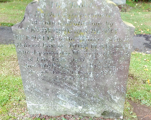Ref: D/369 – **McANALLY**

This tablet erected is a memorial of duty and affection by CATHERINE and HENRY McANALLY to the memory of their beloved parents JOHN McANALLY who departed this life on the 14th day of July 1837 aged 52 years and MARY his wife who died on the 5th day of February 1845 aged 61 years.

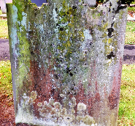Ref: D/370 – **McCORRY/FLEMING**

Illegible – too much erosion

Ref: D/371 – **CAULFIELD** (Unmarked)

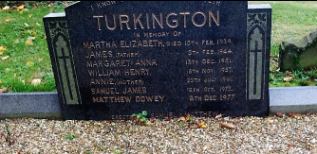Ref: D/372 – **TURKINGTON**

“I know that my Redeemer liveth” In memory of MARTHA ELIZABETH died 15th Feb, 1939; JAMES (Father) died 5th Feb. 1944; MARGARET ANNA died 13th Dec. 1951; WILLIAM HENRY died 18th Nov. 1957; ANNIE (Mother) died 25th July 1961; SAMUEL JAMES died 18th Oct. 1975; MATTHEW DOWEY died 6th Dec. 1977. Erected by Samuel and Matthew.

Ref: D/373 – **TAYLOR** (Unmarked)

Ref: D/374 – **KEARNEY/GREER** (Unmarked)

Ref: D/375 – **BROWN** (Unmarked)

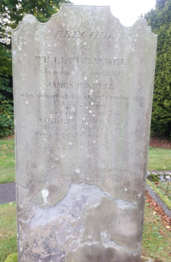Ref: D/376 – **MAXWELL**

Erected by WILLIAM MAXWELL in memory of his father JAMES MAXWELL, who departed this life 21st October 1858, aged 73 years. Also the above named WILLIAM MAXWELL, born 3rd August 1819, died 20th February 1885.

Memorial vase on grave reads: HENRY J. MAXWELL, died 21st November 1961. JANE HOUSTON died 3rd June 1962. EVELYN HADDOCK died 7th September 1962.

(Vase disappeared 2015)

Ref: D/377 Vacant

Ref: D/378 – **GEDDIS**

Ref: D/379 Unknown

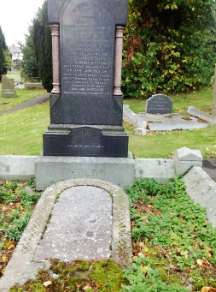Ref: D/380 – **PEDLOW**

In loving memory of MAGGIE, daughter of SAMUEL and MARGARET PEDLOW, who departed this life October 29th 1899 aged 3 years and 11 months. Also the above named SAMUEL PEDLOW who departed this life June 24th 1906 aged 39 years. Also SUSANNA WHITESIDE died August 5th 1917 aged 74 years. WILLIAM JOHN PEDLOW, son of the above SAMUEL PEDLOW, died 27th November 1918 aged 24 years. Also CHARLOTTE E. HORNER, daughter of the above SUSANNA WHITESIDE, died 26th November 1940 aged 76. *“Safe in the arms of Jesus”*

*Stone lying flat on grave:* SAMUEL PELAN of Lurgan in memory of his beloved wife CHARLOTTE, who died 27th July 1871 aged 58 years. Also of his children all of whom died young. Also his daughter, CHARLOTTE PEDLOW, who died 28th January 1975 aged 29 years and his sister LUY BROWN died 25th March 1876 aged 49 years. Also the above named SAMUEL PELAN, who died 28th September 1878 aged 56 years.

Ref: D/381 – **CAVE**

Ref: D/382 Vacant

Ref: D/383 **McVEIGH**

Ref: D/384 Unknown

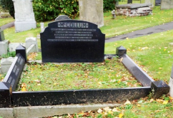Ref: D/385 **McCOLLUM**

Erected by ISABELLA HUNNIFORD and MARY HULL in loving memory of their father ANDREW McCOLLUM, died 12th June 1880. Also his wife, ANN, died 29th June 1909. Also the above named MARY HULL, died 22nd September 1933. Also ADAM McCOLLUM died 22nd December 1895, ROSE McCOLLUM died 30th May 1919, AMELIA CANICH died August 1931

Ref: D/386 – **BLEAKLEY** (Unmarked)

Ref: D/387 – **ROBINSON**

To the memory of JOHN ROBINSON of Monbrief, died 21st April 1923. Also his wife ROSEANN, died 27th May 1897. Also their two sons, JOHN, died 20th August 1925, THOMAS died 22nd March 1932. Also his sister MARIA died 5th January 1917.

Ref: D/388 – **ROBESON**

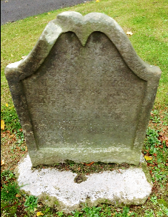Here lieth ye body of JOHN ROBESON who departed this life ye 8th of March 1706 aged 44 years. ANN ROBESON, his wife, died ye 5th of May 1717 aged 64 years

Ref: D/389 – **PATTERNSON/RUSK**

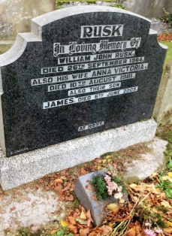In loving memory of WILLIAM JOHN RUSK, died 26th September 1964. Also his wife, ANNA VICTORIA, died 10th August 1981. Also their son JAMES, Died 6TH June 2009 *“At rest”*

(In 1987 there was a small plaque beside main stone inscribed: In loving memory of SARAH J. PATTERNSON died 4th April 1952. This has since disappeared).

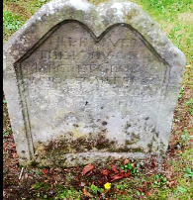Ref: D/390 – **GEORGE**

Here lies the body of MARGARET GEORGE who departed this life 23rd of September 1792 aged 83 years

Ref: D/391 – **MITCHELL** Interments: 12/08/1931; 03/06/1932; 13/10/1936

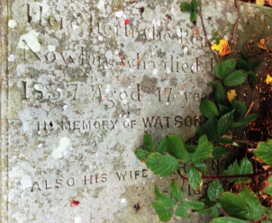Ref: D/392 – **NOWLANN/NOLAN**

Here lieth the remains of JOHN NOWLANN who died January the 2nd 1837 aged 17.

In memory of WATSON NOLAN died 1st April 1849. Also his wife SARAH NOLAN died15th September 1876

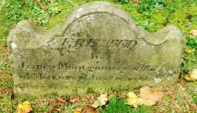Ref: D/393 – **MONTGOMERY**

Erected by JAMES MONTGOMERY of Belfast in memory of his beloved wife MARGARET who died June 12th 1846.

Ref: D/394 – **WINDSOR/TAYLOR** (Unmarked) Interment: 19/12/1950

Ref: D/395 – **CURRAN**

In loving memory of (Left side) JOHN(JACK) CURRAN 1900-1969; ELIZABETH CURRAN nee MAGINN 1901-1980 and their daughters MARY MARGARET (PEGGY) CRAIGIE 1928-1987 (Interred in California); CHARLOTTE (LOTTIE) CURRAN 1925-1968; DINAH CURRAN 1925-2010. (Right side) JOHN CURRAN 1868-1940; MARGARET HANNA CURRAN died 1942; and their daughters DINAH CURRAN 1893-1938; SARAH PORTER 1894-1962 and her son ROBERT PORTER 1923-1985. “Peace perfect peace.”

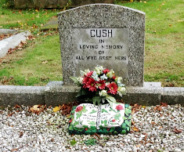Ref: D/396 – **CUSH**

In loving memory of all who rest here

Ref: D/397 – **BURRELL** (Unmarked)

Ref: D/398 – **BUNTING** (Unmarked)

Ref: D/399 – **MORRISON** (Unmarked)

Ref: D/400 – **MAGILL**

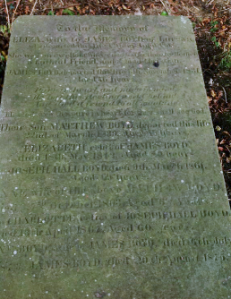Ref: D/401 – **BOYD**

To the memory of ELIZA, wife of JAMES BOYD of Lurgan, who departed this life 12th of April 1808. *She was an excellent wife, a most affectionate mother, a faithful friend and a good Christian.*

JAMES BOYD departed this life 6th November 1831 aged 76 years. *Pure in heart and pure in mind, he left this fleeting world behind, he died a friend to all mankind. Blessed are the pure in heart for they shall see God.*

Their son, MATTHEW BOYD, departed this life 22nd March 1839 aged 45 years, ELIZABETH, relict of JAMES BOYD, died 18th May 1812 aged 80 years.

JOSEPH HALL BOYD died 9th March 1861 aged 69 years. ANNE, wife of the above MATTHEW BOYD, died 7th October 1863 aged 68 years. Also CHARLOTTE, relict of JOSEPH HALL BOYD, died 13th April 1867 aged 60 years. JANE BOYD, wife of JAMES BOYD, died 6th July 1873. JAMES BOYD died 20th August 1875.

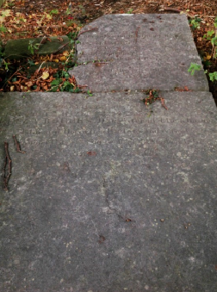

*Not to sorrow is men without hope*

JOHN HAZLETT 1819

JANE, his daughter, wife of ROBERT MANSFIELD, Esqr 1834 ???? the beloved child of ELIZABETH HAZLETT, July 1845 ?????? October 1811. Their daughter DOROTHEA HAZLETT 22nd September 1863. ELIZA ROGERS, daughter of the above JOHN and DOROTHEA HAZLETT, and wife of SAMUEL ROGERS, Surgeon, died 18th June 1861. Also the above named SAMUEL ROGERS, died 9th February 1875

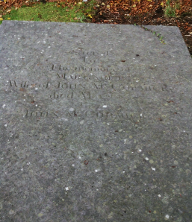Sacred to the memory of MARGARET, wife of JOHN McCORMICK. died May 28th1820.

JOHN McCORMICK

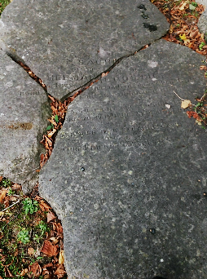

Sacred to the memory of HERMAN ROSTIG, born at Niesky, Silesia, on 11th September 1849. Interred at Lurgan, 5th March 1883.

*A man upright and honourable, a friend faithful and sincere, a stranger in a strange land, our friend sleepeth*.

*Note: The four stones above stood side by side and were originally mounted on pillars*

Ref: D/402 – **STEVENSON**  (Unmarked)

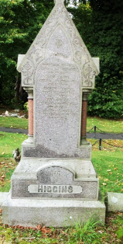Ref: D/403 – **HIGGINS** I.H.S.

In memory of

ELIZABETH HIGGINS who died 20th April 1862 aged 56 years. PETER HIGGINS who died 31st March 1866 aged 20 years. MICHAEL HIGGINS who died 12th July 1873 aged 63 years. JOHN HIGGINS who died 18thth December 1877 aged 41 years. CHARLES HIGGINS who died 13th September 1881 aged 30 years.

R.I.P.

Front of 403 – Tacet

Only word on stone “TACET.” Tradition has this as the grave of a woman possibly a nagging wife or a local gossip. The one word Latin inscription “TACET” means be silent, but traditionally it has been believed to mean ‘She speaks no more’ or ‘Quiet at last.’ This is possibly one of the shortest epitaphs in the world. An article in The Spectator dated 28th July 1884 describes the stone as being “in tolerably good preservation” so at that time it was regarded as old – possibly 17th century.

Ref: D/404 Vacant

Ref: D/405 – **ELLIOTT**

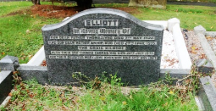In loving memory of our dear father THOMAS who died 7th May 1922 and our dear mother ANNIE who died 27th April 1935. The Craig, Kilmore. Also their son THOMAS GEORGE who died 20th July 1973 and their daughter MARY JANE KNOX who die 14th November 1967.

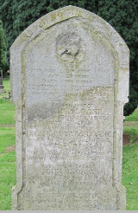Ref: D/406 – **SLOANE**

Sacred to the memory of MARY ANN SLOANE of Lurgan who died 22nd June 1867 aged 21 years. Also her brother JOSEPH R. SLOANE who died 9th March 1869 aged 16 months. Also her sister MAGGIE SLOANE who died 15th April 1875 aged 15 years. Also her sister CHARLOTTE E. SLOANE who died 4tth October 1877 aged 20 years. *“Ye shall be gathered one by one.” Isaiah XXV11* Also their father JOHN SLOANE who died 2nd May 1884 aged 62 years. Also their mother CHERRY SLOANE who died 25th February 1891 aged 70 years.

Ref: D/407 – **DOUGLAS**

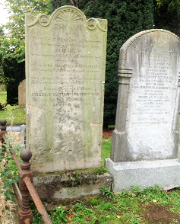*Left stone:* Erected by MOSES DOUGLAS of Kinnego in memory of his beloved wife ELIZABETH, who departed this life 21st October 1853 aged 58 years. Also his daughter CATHERINE, who died 11th June 1847 aged 21 years. “*The righteous dead are but removed from sight, Hid in the lustre of celestial light.”* Also his revered parents MOSES and CATHERINE DOUGLAS. Also son JAMES, wife HANNAH, who died 31st December 1869 aged 26.

*Right stone:* Sacred to the memory of HILLARY DOUGLAS of Kinnego who died 14th June 1849, aged 56 years. Also his wife MARY DOUGLAS who died 21st March 1850 aged 83 years and his daughter MARGARET DOUGLAS who died 21st March 1880 aged 58 years. Also SUSANNAH and MARGARET who died in infancy and his daughter ISABELLA DOUGLAS who died 13th January 1897 aged 76 years and his sons HILLARY DOUGLAS who died 7th September 1915 and HENRY DOUGLAS who died 10th January 1921/ Erected by Henry Douglas of Kinnego.

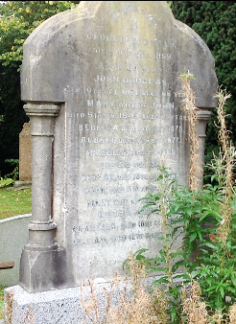

Sacred to the memory of GEORGE DOUGLAS who died 10th December 1869 aged 56 years. JOHN DOUGLAS died 10th October 1871 aged 66 years. MARY, wife of JOHN, died 9th August 1845 aged 35 years. REBECCA died 15th February 1875. Also ROBERT died 12th November 1877. ARABELLA, wife of John, died 3rd December 1902. GEORGE died 16th January 1909. JOHN died 5th April 1922. MARY, wife of GEORGE, died 19th January 1924. ARABELLA died 16th October 1925. WILLIAM died 12th March 1926.

Ref: D/409 - **DOUGLAS**

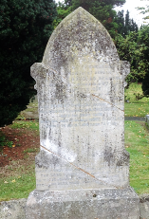In affectionate remembrance of God’s honoured servant HERBERT DOUGLAS of Lurgan, Born 9th January 1895, born again 9th January 1916, died 31st October 1935. *Served the Lord in this land; also in Venezuela for over 13 years.* Also ROBERT DOUGLAS, father of above and beloved husband of ANNIE DOUGLAS, died 1st September 1936. Also the above named ANNIE DOUGLAS died 12th June 1944 aged 82 years.*“Ye must be born again.” John 3.7 “That if thou shalt confess with thy mouth the Lord Jesus, and shalt believe in the heart that God has raised him from the dead, thou shalt be saved.” Rom 10.9*

Ref: D/410 – **RICHARDSON**  (Unmarked)

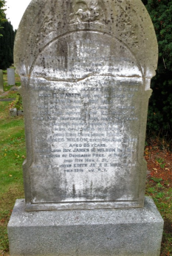Ref: D/411 – **WILSON**

In loving memory of ANNE, beloved wife of SAMUEL WILSON, Portadown, died 29th January 1885. Also their children ANNIE died 6th April 1884 aged 14 years; ANABELLA died 9th January 1886 aged 19 years. Also ELIZABETH, beloved daughter of JAMES and ANNIE WILSON, died 8th January 1880 aged 10 months. Also the above SAMUEL WILSON died 13th November 1916 aged 79 years, and the above named ANNIE, wife of JAMES WILSON, died 2nd December 1943 and JAMES WILSON died 4th March 1944 aged 85 years. Also his son Reverend JAMES S. WILSON, B.A. B.D., Minister of Duncairn Presbyterian Church, Belfast, died 11th November 1951 and his daughter EDITH JANE, B.Mus. L.R.A.M., died 15th November 1951. “Forever with the Lord.”

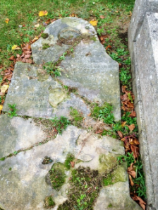Ref: D/412 – **MAGOWAN**

Erected by SAMUEL MAGOWAN of Moyraverty in memory of his beloved daughter ELIZA JANE who died 16th December 1875 aged 14 years. WILLIAM MAGOWAN died 30th September 1922 aged 63 years. Also his wife, MARY MAGOWAN, died 20th September 1925 aged 65 years.

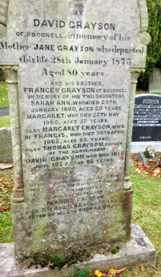Between D/412 and 413 - **GRAYSON**

Erected by DAVID GRAYSON of Boconnell in memory of his mother JANE GRAYSON who departed this life 28th January 1873 aged 80 years. And his brother FRANCIS GRAYSON of Boconnell in memory of his two daughters, SARAH ANN who died 29th January 1880 aged 20 years, MARGARET who died 25th May 1880 aged 32 years. Also MARGARET GRAYSON, wife of FRANCIS, who died 30th April 1882 aged 62 years. Also THOMAS GRAYSON, father of the above named DAVID GRAYSON, died 31st August 1903 aged 76 years. *Inserted by his son Thomas Grayson*.

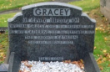Ref: D/413 – **GRACEY**

In loving memory of WILLIAM GRACEY died 19th February 1961, his wife CATHERINE died 3rd September 1971, their daughter KATHLEEN died 14TH February 1927. *“Till He come.”*

Ref: D/414 - **HEIGHTON** (Unmarked)

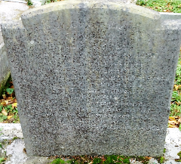Ref: D/415 – **RIDGEWAY**

Sacred to the memory of ROBERT RIDGEWAY who died 23rd November 1852, and of his son WILLIAM who died 21st November 1900. Also his wife MARY ELIZABETH, (nee FRENCH), who died 21st March 1929 and of their children, WILLIAM HENRY, Sergeant, Young Citizens Volunteers, killed in action, Somme, 1st July 1916. RACHEL who died 1st March 1948. CHARLES FRENCH, born June 15th 1890, died December 23rd 1967.

*“Thy will be done.”*

Ref: D/416 – **SEWELL**

Ref: D/417 – **FEARON** (Unmarked)

Ref: D/418 – **MORGAN** (Unmarked)

Ref: D/419 – **MILLS** (Unmarked)

Ref: D/420 – **DOUGLAS/BLACK**

In loving memory of CLARA BLACK who died 20th January 1844. Also her husband WILLIAM BLACK who died 27th April 1844.

Ref: D/421 Vacant

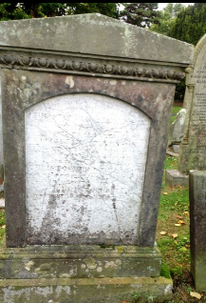Ref: D/422 – **STEVENSON**

Erected by CHRISTOPHER STEVENSON of Derryadd. Sacred to the memory of ELIZABETH STEVENSON his beloved wife who departed this life June 9th 1852 aged 36 years. Also to the above named CHRISTOPHER STEVENSON who went to rest January 29th 1874 and also to their son, CHRISTOPHER died July 6th 1874. *“Whosoever believeth on the Lord …………”*

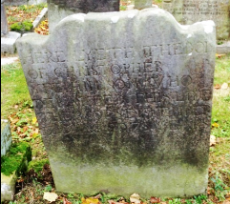

Here lieth the body of CHRISTOPHER STEVENSON who departed this life the 8th of September 1799 aged 78 years.

*(Note: During 1987 survey there was a third stone here but it was broken and illegible*).

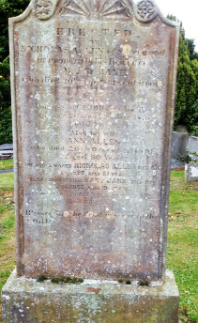Ref: D/423 – **ALLEN**

Erected by NICHOLAS ALLEN of Silverwood in memory of his daughter MARY JANE who died 20th September 1867 aged 21 years. Also his son GEORGE who died in Queensland 12th January 1876 aged 25 years. Also his wife ANN ALLEN who died 20th December 1891 aged 80 years. The above named NICHOLAS ALLEN died 6th February 1895 aged 81 years, his granddaughter MARY JANE died 8th June 1895 aged 19 years. Also his son CHARLES died 1st March 1928 aged 86 years. *“Blessed are the dead who die in the Lord.”*

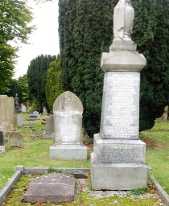Ref: D/424 – **LIVESTON/LIVINGSTON**

*Flat stone on left:* Here lyeth the body of WILLIAM LIVESTON of Legacorry who departed this life July 20th 1774 aged 60 years. Also W.H. Levingston who departed this life May 8th 1847 aged 77 years.

*Obelisk on right*: In memory of JAMES LIVINGSTON of Silverwood died 20th March 1886 aged 65 years. His son HENRY died 23rd March 1888 aged 18 years. His son JOHN died 9th April 1910 aged 48 years. His wife ISABELLA died 4th November 1915 aged 76 years. His grandson JOHN LIVINGSTON, killed 1st July 1916 at Thiepval, France aged 21 years. ELIZABETH wife of JOHN LIVINGSTON who died 28th June 1923 aged 53 years. Also their son JAMES LIVINGSTON who died 13th July 1954. *Left face:* Also their son WILLIAM LIVINGSTON who died 7th May 1934.

Ref: D/425 – **HANNA**

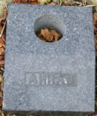

Ref: D/426 Unknown

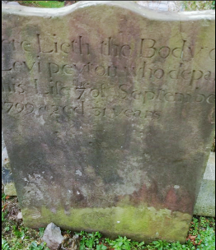Ref: D/427 - **PEYTON**

Here lieth the body of LEVI PEYTON who departed this life 7th of September 1799 aged 31 years.

*(Note*: In 1987 there were parts of another small broken stone on this grave. The only inscription left was – July 1918. *“Thy will be done.”* )

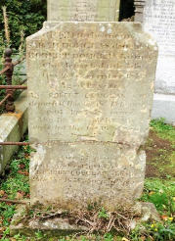Ref: D/428 – **DOUGLAS**

Sacred to the memory of SARAH DOUGLAS, daughter of ROBERT DOUGLAS, who departed this life the 2nd December 1850 aged 10 years. ROBERT DOUGLAS departed this life 18th February 1867 aged 78 years. Also his wife MARY who departed this life 19th April 1868 aged 77 years. NATHANIEL DOUGLAS who died 16th September 1872 aged 57 years. *“In the midst of life we are in death*.” Also JOHN DOUGLAS who died 26th November 1878 aged 66 years.

Ref: D/429 – **ABERNEATHY** (Unmarked)

Ref: D/430 Unknown

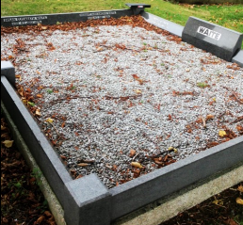Ref: D/431 – **WAITE**

JAMES WAITE died 20th October 1929. MARY ELIZABETH WAITE died 5th February 1934. In loving memory of FREDERICK THOMAS SALMON died 14th October 1957. Also his wife MARGARET ELLEN died 3rd January 1987. ROBERT ALEXANDER WAITE died 4th November 1918. SUSAN ELIZABETH WAITE died 4th July 1975.

Ref: D/432 Unknown

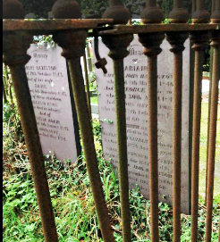Ref: D/433 – **HAZELTON**

*Left stone:* In memory of ROBERT HAZELTON who died 19th October 1843 and of his wife JANE who died6th December 1847. Also of their children, WILLIAM KNOX who died in infancy and of LETITIA ADAIR who died the 6th August 1845. ANNA GRAY who died May 1874

*Right stone:* In memory of MARIANNE, wife of JOHN HAZELTON, who died 8th March 1846, and of GEORGE their son who died 30th April 1847, and of JOHN HAZELTON who died 12th February 1878 aged 60 years. EDITH HAZELTON who died in infancy. ELIZABETH HAZELTON who died 1st October 1874 aged 22 years. CHARLES EDWARD HAZELTON who died 26th June 1881 aged 15 years. LUCINDA JANE HAZELTON died 20th September 1885 aged 64 years. GEORGE HAZELTON who died 17th October 1910 aged 57 years.

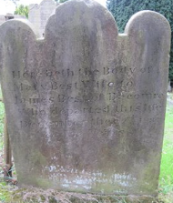Ref: D/434 – **BEST**

Here lieth the body of MARY BEST wife of JAMES BEST of Bocomra who departed this life December 22nd 1831 aged 73 years.

Ref: D/435 – **WOODS** (Unmarked)

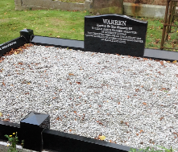Ref: D/436 – **WARREN**

Erected to the memory of WILLIAM JAMES WARREN (SOLICITOR) of Monbrief Lurgan who departed this life on 10th January 1938. Loving husband of AILEEN and devoted father of RONALD and CYRIL.

*Side panel*: MARY ANN WARREN 26/08/1904 MATTHEW WARREN 22/02/1905

(This memorial has been erected since 1988)

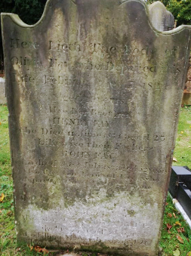Ref: D/437 – **FAY**

Here lieth the body of OLIVIA FAY who departed this life February 15th 1824 aged 11 years. Also her brother HENRY FAY who died 11th June 1854 aged 25 years. Likewise their father JOHN FAY who died 4th July 1855 aged 52 years. Also his son BERNARD FAY who departed this life 20th June ???? aged 2? Years and JANE FAY who died 18th October 1851 and MARY CAMPBELL who died 12th December 1853 aged 31 years. Also ELLINER McVEIGH who died 26th ????? 1853 aged ??

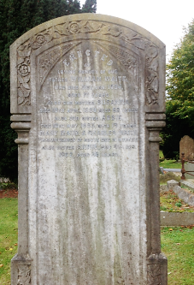Ref: D/438 – WAITE

Erected to the memory of our father WILLIAM WAITE who died 31st January 1894 aged 71 years. Our mother SUSANNA died 19th April 1989 aged 62 years. Also our sister ABBIE died 16th May 1893 aged 19 years. MARY, MAUDE and CHARLES WAITE, grandchildren of the above died in infancy. Also sister ANNIE died 8th December 1902 aged 36 years. *“Forever with the Lord.”*

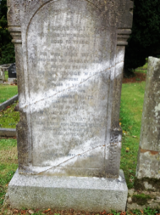In loving memory of THOMAS WAITE who died 21st March 1895 aged 70 years. Also his wife JANE WAITE who died 13th January 1898 aged 72 years. His son GEORGE WAITE died 30th June 1872 aged 20 years. Also their son Rev. THOMAS WAITE died 23rd May 1901 aged 32 years. Their grandson JOSHUA WAITE who died 13th June 1915 aged 23 years. Also their son JOSHUA WAITE who died 28th July 1922 aged 74 years.

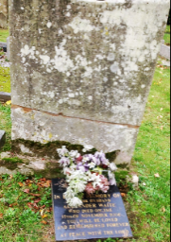

Large stone: Illegible

Memorial vase: In loving memory of a dear husband ALEXANDER WAITE who died 12th November 2006*. “You will be loved and remembered forever. At peace with the Lord.”*

Ref: D/439 Vacant

Ref: D/440 – **MCDOWELL/BOYLE** (Unmarked)

Ref: D/441 – **ALLEN** (Unmarked)

Ref: D/442 – **ORR** (Unmarked)/**BLACK** (Unmarked tomb)

Ref: D/443 – **ELLIS** (Unmarked)

Ref: D/444 – **McDOWELL**

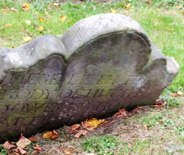

Here lieth the body of HUGH MCDOWELL who died -------- (remainder of stone below ground)

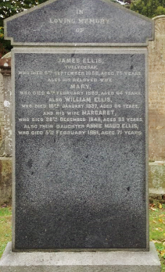Ref: D/445 – **ELLIS**

In loving memory of JAMES ELLIS, Tullydegan, who died 5th September 1888, aged 75 years. Also his beloved wife, MARY, who died 4th February 1889, aged 64 years. Also WILLIAM ELLIS who died 18th January 1937, aged 34 years. Also his wife, MARGARET, who died 26th December 1948, aged 93 years. Also their daughter, ANNIE MAUD ELLIS, who died 5th February 1961, aged 71 years.

*(Note: This stone has been replaced as when surveyed in 1988 the original stone was broken and not on the grave*).

Ref: D/446 – **SOMERVILLE** (Unmarked)

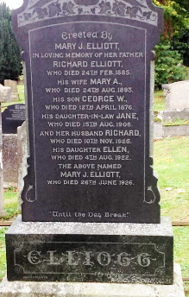Ref: D/447 – **ELLIOTT** (1927)

Erected by MARY J. ELLIOTT in loving memory of her father, RICHARD ELLIOTT, who died 24th August 1893. His son, GEORGE W. who died 12th April 1876. Hid daughter-in-law JANE, died 15th August 1905. Also her husband RICHARD, who died 10th November 1925, his daughter ELLEN who died 4th August 1922. The above named MARY J. ELLIOTT who die 26th June 1926. *“Until the day break.”*

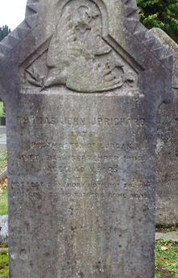Ref: D/448 – **UPRICHARD**

THOMAS JOHN UPRICHARD, late Postmaster of Lurgan, died 24th September 1901, aged 40 years. “Not lost to memory, not lost to love, but gone to his Father’s home above.”

Ref: D/449 – **ELLIOTT**

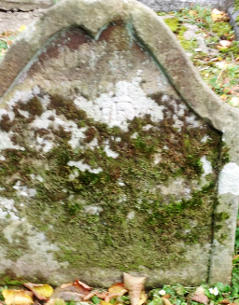Here lieth the body of ---------- ELLIOTT.

Ref: D/450 – **WILLIAMSON** (Unmarked)

Ref: D/451 – **PEDLOW**

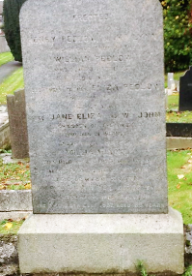Erected by HENRY PEDLOW and MRS LYNN in memory of their father, WILLIAM PEDLOW, who died 20th April 1877 aged 60 years. Also their mother, ELIZA PEDLOW, who died 4th April 1873 aged 52 years. Also JANE ELIZA & WILLIAM JOHN, children of the above, who died in infancy. Also their grandson, WILLIAM LYNN, who died 7th December 1883 aged 1 year. Also the above named J.E. LYNN, beloved wife of S.A. LYNN, who died 6th July 1923 aged 72 years. Also the above named S.A. LYNN, who died 28th December 1937, aged 86 years.

Ref: D/452 Vacant

Ref: D/453 – **WILSON**  (Unmarked)

Ref: D/454 – **CONNOR** (Unmarked)

Ref: D/455 – **IRWIN** (Unmarked)

Ref: D/456 – **HUTCHINSON**

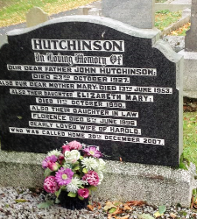In loving memory of our dear father JOHN HUTCHINSON, died 23rd October 1927. Also our dear mother, MARY, died 13th June 1953. Also their daughter ELIZABETH MARY died 11th October 1990. Also their daughter-in-law FLORENCE died 6th June 1996, dearly loved wife of HAROLD who was called Home 30th December 2007 “At rest”

Ref: D/457 – **SPEERS** (Unmarked)

Ref: D/458 – **DUKE**  (Unmarked)

Ref: D/459 – **HADSKIS**

Here lieth the body of ISRAEL HADSKIS, who departed this life the 13th of March 1716 aged 60 years.

Ref: D/460 Vacant

Ref: D/461 – **SATH LV**

Here lieth the body of CORNELIES SATH-LV who departed this life ye 29th day of March 1779 aged 42 years.

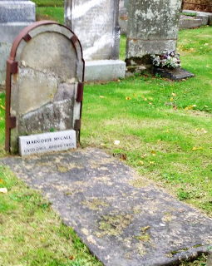Ref: D/462 **– McCALL** (1706)

JOHN McCALL (inscription illegible)

MARJORIE McCALL – “Lived once, buried twice,”

Ref: D/463 – **GREER** (Unmarked)

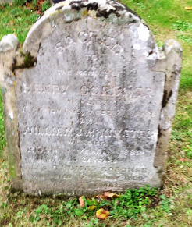Ref: D/464 – **CORDNER**

Sacred to the memory of HENRY CORDNER, who died 1st March 1889 aged 21 years. Also WILLIAM J. McKINSTRY, who died 20th November 1885, aged 22 years. Also THOMAS CORDNER, who died 12th July 1899 aged 44, also MARY CORDNER, died 5th February 1900;

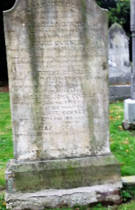Erected by WILLIAM JOHN CORNER in memory of his beloved wife ISABELLA, who died 26th May 1889 aged 40 years. Also his daughter ANNIE CORNER who died 24th March 1881 aged 5 years. *“How joyful the hope of the first resurrection. Also hope of asceneration.”* Also his daughter CATHERINE CORNER who died 4th February 1889 aged 24 years. *“When He cometh to his Kingdom.*” Also the above named WILLIAM JOHN CORNER who died 22nd March 1916 in his 81st year. Also his daughter, MAGGIE CORNER, who died 26th February 1933, aged 64 years*. “For here we have no continuing city, but we see one to come.”* Hebrews X111 1V

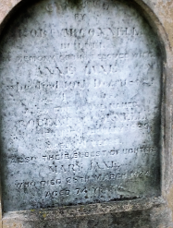Ref: D/465 – **McCONNELL**

Erected by ROBERT McCONNELL, B??? DER, in memory of his beloved wife, ANNE JANE, who died 10th December 1862 aged 31 years. Also the above named ROBERT McCONNELL, who died 18th January 1889 aged 61 years. Also their eldest daughter, MARY JANE, who died 28th March 1924 aged 74 years,

Ref: D/466 – **STEWART** (Flat stone on railings - 1988)

General Stewart

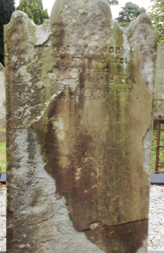Ref: D/467 – **NELSON**

-----------------May 1881 aged --- years. Also his wife, REBECCA ------ who died -------September 1903 aged 70 years.

Between 467 & 468 – **BURLEIGH**

Here lieth the body of ELIZABETH BURLEIGH, wife of WILLIAM BURLEIGH, who departed this life December ye 21st 1733 aged 36 years, Also their children ------- (remainder buried in the ground)

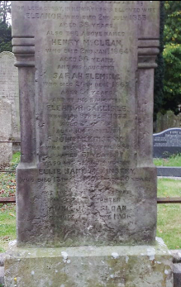Ref: D/468 **McCLEAN**

HENRY McCLEAN of Legacurry in memory of his beloved wife ELEANOR, who died 2nd July 1853 aged 39 years. Also the above named HENRY McCLEAN, who died 2nd January 1864 aged 56 years. Also his daughter SARAH FLEMMING, who died 26th December 1867 aged 24 years and of his daughter ELEANOR CARLISLE, who died 9th December 1873 aged 28 years. Also his son-in-law JOHN McKINSTRY, who died 10th April 1880 aged 31 years. Also his granddaughter ELLIE JANE McKINSTRY, who died 13th ------- 1896 aged 20 years*. “Not lost but gone before.”* Also his daughter ANNIE JANE SLOAN, who died 2nd June 1906.

Ref: D/469 Vacant

Ref: D/470 – **HAZELTON**

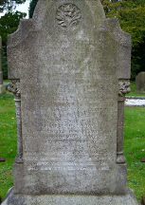In loving memory of HAMILTON HAZELTON, who departed this life 20th April 1879 aged 61 years. Also ROBERT HAZELWOOD of Silverwood, who died 27th July 1844 aged 62 years and of his beloved wife ELIZABETH, who died 20th June 1849 aged 61 years. Also ELIZABETH, the beloved wife of HAMILTON HAZELTON, who died 30th December 1879 aged 65 years and their son CHARLES HAZELTON, who died 13th July 1892 aged 35 years. Also MINNIE, wife of above CHARLES, who died 21st February 1929 aged 70 years. Also their son ROBERT HAZELTON, beloved husband of GERTRUDE HAZELTON, who died 29th June 1937 aged 69 years.

Ref: D/471 – **HAZLETT** (Tomb in railings – 4 pillars with slab – 1988)

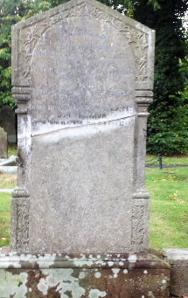Ref: D/472 - **HANCOCK**

In memory of JOHN HANCOCK, born 26th July 1817, died 7th June 1887 and of LUCY, his wife, born 9th May 1814, died 27th February 1895 and of their sons JOHN, born 3rd August 1845, died 27th February 1852, HENRY LAK??, born 6th July 1853, died 27th September 1863, JOHN ARTHUR, born 18th September 1856. Died 6th November 1882.

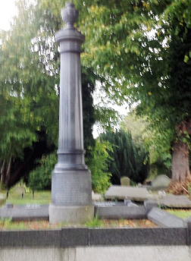Ref: D/473 – **HEWITT**

In affectionate remembrance of HOLT MONTGOMERY HEWITT, who died 7th May 1890 aged 41 years and his mother, JANE, who died 7th December 1902 aged 82 years. Also his brother ADAM HEWITT, who died 1st March 1912 aged 58 years. Also ANNIE, beloved wife of ADAM HEWITT, who died 14th May 1927 aged 69 years. Also their son ADAM HEWITT, died 11th July 1924 aged 32 years. Side stone: WILLIAM HEWITT, killed in action in France, June 1916 aged 35 years. Also HARRIETT, wife of WILLIAM HEWITT, who died 1st May 1907 aged 27 years. HOLT MONTGOMERY HEWITT died 9th September 1972.

Ref: D/474 – **MATHERS** (Unmarked)

Ref: D/475 – **LYNASS**

Ref: D/476 – **BURNS** (Unmarked)

Ref: D/477 – **CULBERT**  (Unmarked)

Ref: D/478 – **FORDE**

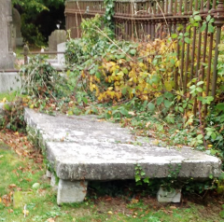The Rev. ARTHUR FORDE, late Rector of this parish, died the twenty fourth day of December, one thousand seven hundred and fifty seven in the fifty sixth year of his age and is interred here (in the north side of the churchyard) agreeably to the special appointment of his Will in order as he himself expresseth to remove that superstitious imagination which prevails among many that such part is profane and unholy. ALICE, his wife, who died September 1792 in the 92nd year of her age.

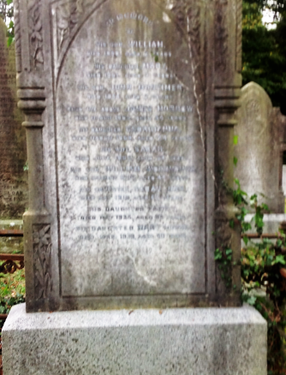Ref: D/479 – **MORROW**

Family burying ground of JAMES MORROW In memory of his son WILLIAM, died 1850 aged 2 years, his daughter MARY, died 1851 aged 9 years, his son JOHN MORTIMER, died 1854 aged 2 years. Also the above named JAMES MORROW, died March 1865 age 54 years. His daughter GEORGIANNA, died March 1869 aged 24. His wife SARRAH, died June 1885 aged 64 years. His son WILLIAM WOODHOUSE, died January 1896 aged 44 years. His daughter SARAH JANE, died May 1912, aged 62 years. His daughter FANNY, died May 1935 aged 88 years. His daughter MARY (MINNIE) died April 1939 aged 80 years.

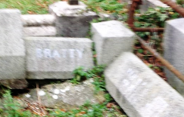Ref: D/480 – **WARRON**

WARRON

Most of the inscription is illegible.

WILLIAM BRATTY died ------------

(Further interment 28/06/1934)

Ref: D/481 – **DIXON** (stone surround – writing illegible)

Ref: D/482 – **SHEPHERD**

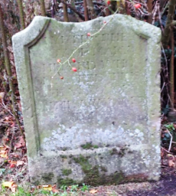Here lieth the body of MARY SHEPHERD, who departed ye life ye 20th April 1711 aged 38 years.

Ref: D/483 – **COULTER** (stone – writing illegible)

Ref: D/484 – **HYNES** (Unmarked)

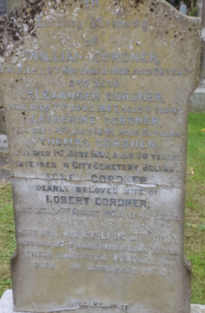Ref: D/485 – **CORDNER**

In loving memory of WILLIAM CORDNER, who died 25th November 1902 aged 76 years and also ALEXANDER CORDNER, who died 7th April 1887 aged 6 years. CATHERINE CORDNER, who died 4th July 1895 aged 31 years. THOMAS CORDNER, who died 1st June 1897 aged 30 years, interred in City Cemetery Belfast. AGNES CORDNER, dearly beloved wife of ROBERT CORDNER, who died 4th August 1918 aged 40 years. MARY CORDNER, wife of above WILLIAM CORDNER, who died 27th June 1919 aged 85 years. Their daughter MARGARET, died 7th September 1939. *“Till He come.”*

Ref: D/486 – **DOUAY** (writing completely illegible)

Ref: D/487 – **CARTWRIGHT** (Unmarked)

Ref: D/488 – **TURKINGTON** (Unmarked)

Ref: D/489 – **WETHERALL**

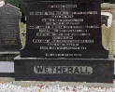In loving memory of RICHARD WETHERALL, died 15th April 1910, also his wife ANNIE, died 8th April 1940. Also their daughters, MAUD MARY REBEKAH, died 21st February 1897, JOSEPHINE, died 29th April 1897, GERTRUDE died 18th November 1898 and their son WILLIAM JOHN, died 15th December 1952. Also their daughter EDITH, died 21st January 1964. *“The Lord is my Shepherd.”*

Ref: D/490 – **WETHERALL**

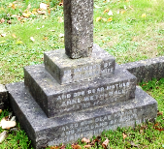In memory of my beloved wife and our dear mother ANNE WETHERALL, died 13th March 1951. Also our dear father WILLIAM JOHN WETHERALL, died 10th January 1956.

Here lieth the body of JEAN STUART & JOHN SMITH & JEAN SMITH. HUGH HAWKINGS

Ref: D/491 – **TAYLOR**

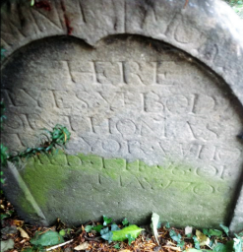Here lieth the body of THOMAS TAYLOR who died 16th May 1709

Ref: D/492 – **JENNINGS** (Unmarked)

Ref: D/493 – **LAVERY** (Unmarked)

Ref: D/494 – **BURRELL** (Unmarked)

Ref:D/495

Ref: D/496 – **THOMPSON** (Unmarked)

Ref: D/497 – **TURKINGTON**

Dedicated to the memory of the late JAMES TURKINGTON of Lurgan, who departed this life the 10th day of October 1832 aged – years. Also his daughter JANE TURKINGTON, who departed this life the – day of January 1852 aged 17 years. “*Precious in the eyes of the Lord*.” His daughter ELIZABETH TURKINGTON, who departed this life 5th July 1811 aged 17 years. Also his son JOHN TURKINGTON, who departed this life 22nd March 1810 aged 23 years.

Ref: D/498 – **TURKINGTON**  (Unmarked)

Ref: D/499 – **THOMPSON**

Ref: D/500 Unknown

Ref: D/501 - **CLARKE**

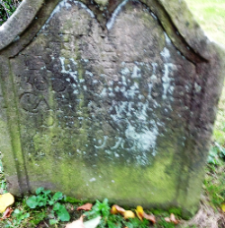Here lieth the body of ALICE CLARKE, who died November 18th 1707.

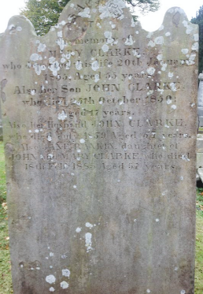 Sacred to the memory of MARY CLARKE, who departed this life 20th January 1855 aged 55 years. Also her son JOHN CLARKE, who died 25th October 1850 aged 17 years. Also her husband JOHN CLARKE, who died 6th July 1850 aged 57 years. Also JANE RANKIN, daughter of JOHN and MARY CLARKE, who died 18th February 1883 aged 57 years.

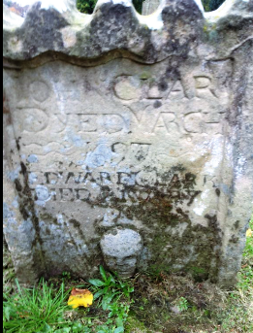JOHN CLARKE died March 1697, EDWARD CLARKE, died January 1705

Ref: D/502 – **LYNAS** (Unmarked)

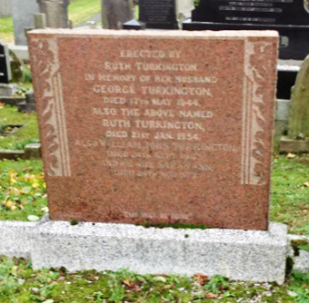Ref: D/503 – **TURKINGTON**

Erected by RUTH TURKINGTON in memory of her husband GEORGE TURKINGTON, died 17th May 1944. Also the above named RUTH TURKINGTON, died 21st January 1954. Also WILLIAM JOHN TURKINGTON, died 24th September 1943 and his wife SARAH ANNE, died 24th November 1972. “*Thy will be done.”*

Ref: D/504 – **CALVERT** (Unmarked)

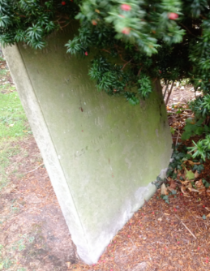Ref: D/505 – **BALLINTYNE**

Sacred to the memory of ARABELLA BALLINTYNE, who departed this life 26th May 1842 aged 66 years. Erected by her sorrowing children as a small tribute of respect to her many virtues. Also her son-in-law THOMAS LAVERY, who fell asleep in Jesus, March 15th 1866 aged 62 years. Also MINNIE and ROY YOUNG who died in infancy.

Ref: D/506 – **HAIRE** (Unmarked)

C. HAIRE

Ref: D/507 Unknown

Ref: D/508 – **FLEMING**

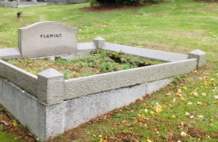

Ref; D/509 – Vacant

Ref: D/510 - **CALLAGHAN/HOLLIDAY** (Unmarked)

Ref: D/511 – **PHAIR**

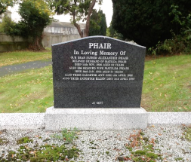In loving memory of our dear father ALEXANDER PHAIR, beloved husband of MATILDA PHAIR, late Coy, SGT MAJOR R.I.R., died 14th November 1936 aged 63 years. Also his beloved wife MATILDA PHAIR, died 2nd January 1958 aged 81 years. Also their daughter ANN, died 4th April 1982. *“At rest.”*

Ref: D/512 – **LAVERY**

In loving memory of our dear mother RACHEL HUTCHINSON LAVERY, beloved wife of ROBERT JOHN LAVERY, who died 10th March 1949. Our dear father ROBERT JOHN LAVERY, who died 23rd October 1958. *“Faithful until the end.”*

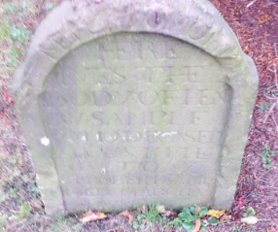Ref: D/513 – **SAMPLE**

Here lieth the body of HENRY SAMPLE, who deceased August 8th 1702. Also ROBERT SAMPLE …..(rest of stone buried in the ground).

Ref: D/514 – Unknown

Ref: D/515 – **COULTER** (Unmarked)

Ref: D/516 – **CAPPERS** (small stone – writing illegible)

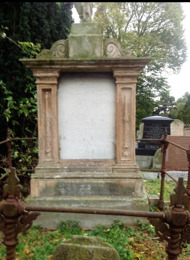Ref: D/517 – **TATE**

Sacred to the memory of DAWSON TATE, Derryadd House, departed this life 8th June 1876 aged 81 years, also his daughter ANN JANE TATE, who departed this life 29th August 1875 aged 34 years. Also his wife DOROTHEA TATE, who departed this life 15th October 1893 aged 78 years. Also his son SAMUEL TATE M.D. who departed this life 2nd September 1934 aged 82 years. *“They are gathering here one by* one.” Erected by his sorrowing widow DOROTHEA TATE, JOHN TATE, son of DAWSON TATE interred into rest 12th September 1892. *“He giveth his beloved sleep.”* Verse 2 Psalm CXVII

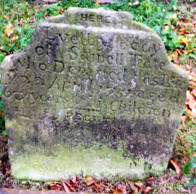Here lyeth ye body of SAMUELL TEATE who departed this life ye 22 April 1751 aged 63 years & his children.

Ref: D/518 – **McCORMICK**

Here lieth the body of JAMES McCORMICK, who departed this life August 7th 1789 aged 75 years. Also JANE his wife, and two children

Ref: D/519 – **LYNESS/STEVENS**

Memorial vase: In loving memory of SAMUEL LYNESS from his affectionate son MARTIN and family circle.

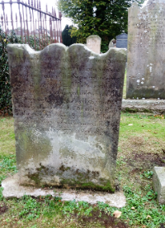This stone was erected by WILLIAM STEVENS, who departed this life September 9th 1791 aged 52 years. Also the body of his dead wife, MARY STEVENS, who departed this life October 9th 1791 aged 56 years. The body of his son THOMAS, who departed this life 21st of May 1792 aged 28 years. Also his daughter MARY who departed this life 21st October 1791 aged 18 years.

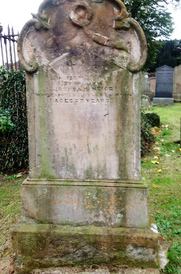Ref: D/520 – **McNIECE**

Erected by MARY McNIECE of Lurgan in memory of her husband JOSHUA, who departed this life 24th February 1870 aged 63 years

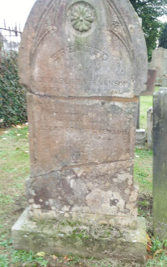Ref: D/521 – **STEVENSON**

Erected by ELIZABETH STEVENSON in memory of her husband THOMAS STEVENSON, Clanrolla, died 21st October 1883 aged 85 years. In loving memory of the above named ELIZABETH STEVENSON, died 5th May 1900, aged 81 years. *“Peace, perfect peace.”*

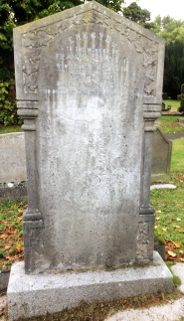

Erected to the memory of FRANCIS GRAYSON, who died 28th February 1840 aged 42 years. Also his wife RACHEL whom died 6th January 1892 aged 92 years.

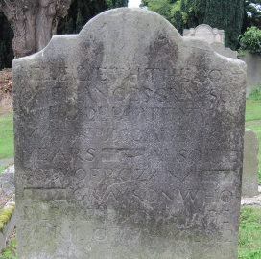

Here lyeth the body of FRANCIS GRAYSON who departed this life 8th May 1750 aged 66 years Also body of his wife ROZANA GRAYSON who departed this life – April 1772 (?) aged 82.

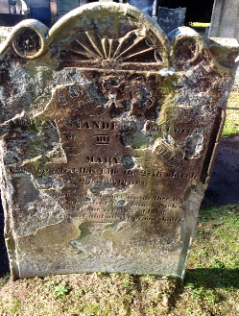Ref: E/522 – **STANFIELD** (Vacant in Register)

Erected by ANDREW STANFIELD of Lurgan in memory of his beloved wife MARY, who departed this life 28th March 1849, aged 19 years. *“How loved, how valued once, avails thee not; to whom related, or by whom begot; A heap of dust alone remains of thee. ‘Tis all thou art and all the proud shall be.”*

Ref: E/523 – **NEILL** (Unmarked) Interment: 26/04/1936

Ref: E/524 – **BOYD**

Erected by THOMAS BOYD in memory of his son THOMAS, who died 7th March 1877 aged 29 years. Also the above THOMAS BOYD, who died 12th June 1894 aged 85 years. Also his wife, ELIZA, died 27th February 1902 aged 93 years. Also HENRY BOYD, who died 21st September 1908 aged 67 years. ELIZA JANE, who died 3rd November 1919 aged 80 years. ELENOR BOYD, who died 28th February 1925 aged 85 years. JAMES BOYD, who died 27th October 1929 aged 57 years.

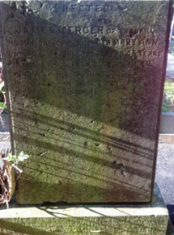Ref: E/525 – **MERCER**

Erected by JAMES MERCER of Shankill in memory of his mother MARY ANN, who died 1st June 1856 aged 45 years. Also his father JAMES MERCER, died 10th November 1876 aged 65 years. Also their son JAMES, died 16th December 1892 aged 41 years.

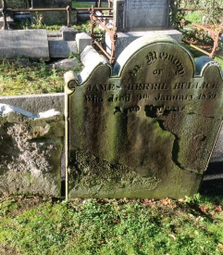Ref: E/526 – **BULLICK**

In memory of JAMES BERRIL BULLICK, who died the 9th January 1859 aged 39 years.

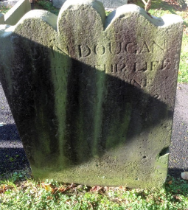Ref: E/527 – **DOUGAN**

JOHN DOUGAN, who departed this life on the 10th day of June 1802 aged 66 years.

Ref: E/528 – Vacant

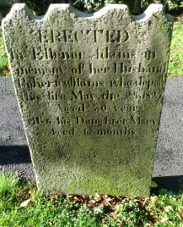Ref: E/529 – **ADAMS**

Erected by ELLENOR ADAMS in memory of her husband, ROBERT ADAMS, who departed this life May the 25th 1827 aged 80 years. Also his daughter MARY aged 16 months.

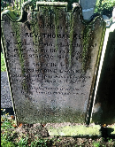Ref: E/530 – **METHODIST BODY - KERR/JOHNSTON**

In memory of the Rev. THOMAS KERR, Wesleyan Minister, who exchanged mortality for life at Lurgan on the 9th of May 1846 aged 81 and of his wife CATHERINE EVANS (KERR), who fell asleep in Jesus at Lurgan on the 12th of April 1645 aged 86 years*. “The righteous shall be held in everlasting remembrance.”*

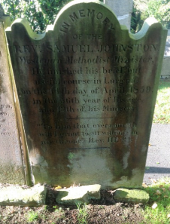

In memory of the Rev. SAMUEL JOHNSTON, Wesleyan Methodist Minister, He finished his brief but useful course in Lurgan on the 14th day of April 1859 in the 56th year of his age and the 12th of his Ministry*. “To him that overcometh will I grant to sit with Me on my Throne.”* Rev.111.21.

Ref: E/531 – Unknown

Ref: E/532 – **JACKSON** (Unmarked) Interment: 28/06/1956

Ref: E/533 – Vacant

Ref: E/534 – **JOHNSTON** (Unmarked)

Ref: E/535 – Unknown

Ref: E/536 – **JOHNSTON**

Ref: E/537 – Space

Ref: E/538 – Vacant

Ref: E/539 – **ELLIOTT**

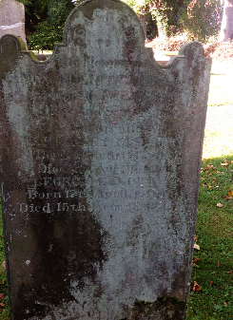Sacred to the memory of JAMES ELLIOT of Blough, born 6th February 1778, died 2nd September 1845, and his wife MARGARET ELLIOTT, born26th October 1781, died 6th August, 1862. GEORGE ELLIOTT, born 17th April 18??, died 15th January 1870.

Ref: E/540 – Unknown

Ref: E/541 – Neill

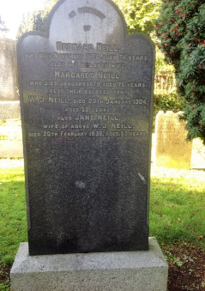In memory of BERNARD NEILL, who died November 1876, aged 74 years, also his beloved wife MARGARET NEILL, who died January 1879, aged 76 years. Also their beloved son W. J. NEILL, died 29th January 1904 aged 59 years. Also JANE NEILL, wife of the above W.J.NEILL, died 20th February 1936 aged 93 years.

Ref: E/542 – **NEILL**

In memory of BERNARD NEILL, who died November 1876, aged 74 years, also his beloved wife MARGARET NEILL, who died January 1879, aged 76 years. Also their beloved son W. J. NEILL, died 29th January 1904 aged 59 years. Also JANE NEILL, wife of the above W.J.NEILL, died 20th February 1936 aged 93 years.

Ref: E/543 – Vacant

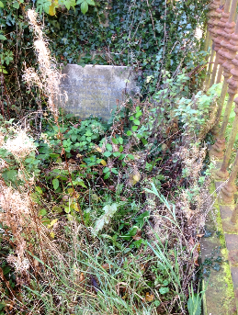Ref: E/544 – **MALCOLM**

Sacred to the memory of GEORGE PENTLAND MALCOLM, who died 18th June 1855 aged 21 years 5 months. SAMUEL MALCOLM Esq., who died 6th October 1861 aged 21 years. CHARLOTTE MALCOLM who died 2nd November 1861 age 19 years. Also JAMES MALCOLM Esq., their father, who died 5th February 1864 aged 76 years. Also of CHARLOTTE MALCOLM their mother, who departed this life 1st August 1870 at Longbranch, America, aged 64 years.

*Second stone*: This tablet is erected to the memory of THOMAS PENTLAND Esq., who departed this life January 19th 1860, by his bereaved wife and also to their two infant sons.

Ref: E/545 – Unknown

Ref: E/546 – **McMULLAN**

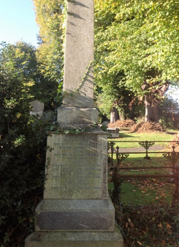In memory of JOHN McMULLAN, born September 1770, died December 1833 and his wife ANNE, born October 1766, died April 1846. Also JOHN, son of JOHN and ANNE McMULLAN, born September 1797, died August 1888.

Ref: E/547 – **NEILL**

In loving memory of CHARLES NEILL, who died 20th June 1918. Also ELIZABETH NEILL, his wife, who died 15th November 1921. Also CHARLES WILLIAM NEILL, their son, who died 20th August 1945. Also LETITIA NEILL, wife of JAMES NEILL, who died 18th November 1946. Also ROBERT NEILL, their son, who died 17th February 1951. CHRISTINA ALICE, wife of CHARLES WILLIAM NEILL, who died 25th April 1961. Also the above JAMES NEILL, their son, who died 8th December 1961. MARY, wife of above ROBERT NEILL, died 20th October 1972.

Ref: E/548 – Unknown

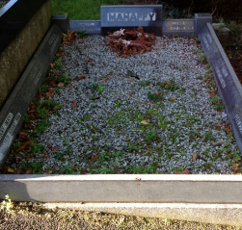Ref: E/549 – **MAHAFFEY**

SAMUEL died 23rd November 1936. SAMUEL died 3rd May 1973. JANE died 6th February 1939. FLORENCE died 14th August 1931. ETHEL died 27th November 1950. HARRY died 5th August 1955. CATHERINE did 26th June 1966

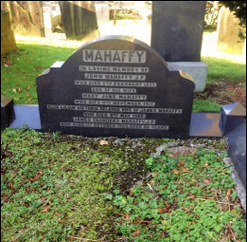

In loving memory of JOHN MAHAFFEY J.P., who die 5th February 1933 and of his wife, MARY JANE MAHAFFEY, died 11th November 1915. Also LILIAN VICTORIA, beloved wife of JAMES MAHAFFEY, who died 8th May 1966. Also JAMES SAUNDERS MAHAFFEY J.P. who died 1st October 1959 aged 90 years.

Ref: E/550 – Vacant

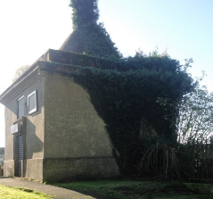Ref: E/551 – **BROWNLOW**

*There are two plaques on the outside wall of the BROWNLOW vault which read as follows*:

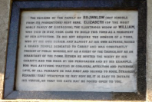“The remains of the family of BROWNLOW (not ignoble from its foundations) rest here. ELIZABETH (of the most noble family of ABERCORN) the illustrious widow OF WILLIAM, who died in 1737, took care to build this tomb as a monument of her affection. He did not require the honour of a tomb, who, by his own design, and almost at his own expense, raised a grand temple dedicated to Christ, and was constantly present at public worship, not as a guest of the Church, but as an inhabitant of the town. Hither he invited the needy by his charity, and the meek by his persuasion and by his example. Nor was anything wanting in conjugal affection and paternal love, of all he was perhaps first and second to none. Stranger remark! That whatever he may now be, it is easy to initiate his virtue, so that the gate may be found open to you.”

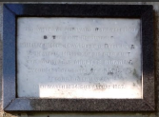“This vault was renovated in the year 1959 by the Right Honourable WILLIAM GEORGE EDWARD, FOURTH BARON LURGAN, in grateful memory of his dear aunt the HONOURABLE ANNETTE BROWNLOW, youngest daughter of CHARLES SECOND BARON LURGAN, Born March 1874, Died August 1967.”

Ref: E/552 – Vacant

Ref: E/553 – **ROBINSON**

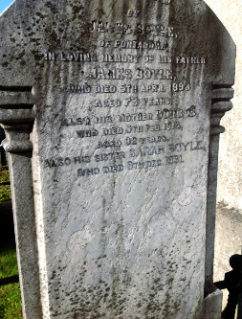Ref: E/554 – **BOYLE**

Erected by JAMES BOYLE of Portadown in loving memory of his father JAMES BOYLE, who died 5th April 1893, aged 73 years. Also his mother DORCAS, who died 5th February 1913, aged 92 years. Also his sister SARAH BOYLE, who died 9th December 1931. “*Gone, not from memory, not from love, but to the Father’s House above.”*

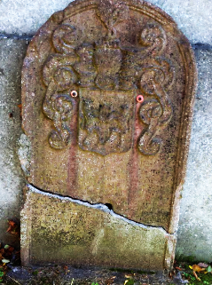**O’REILLY**

*In 1988 this stone lay broken at the rear of the Brownlow vault. It has been repaired and is bolted to the back wall of the vault. The inscription is in Latin – the only one in the graveyard. The following is a translation of the inscription:-*

“Here lies the body of JANE O’REILLY, she lived uprightly in wedlock with MYLES O’REILLY thirty five years, and she departed this life on 19th day of December 1715, in the 54th year of her age, in memory of whom this monument stands erected at the expense of JAMES O’REILLY, her war like son, and eldest by birth.”

Ref: F/555 – **HUGHES** (Unmarked)

Ref: F/556 – **ALLEN**

Erected by EDWARD ALLEN of Taugheran in memory of his wife ELIZABETH, who died 23rd September 1876 aged 40 years. “Blessed are the dead who die in the Lord.”

Ref: F/557 – **CUNNUNGHAM**

Here lieth ye body of RICHARD CUNNINGHAM who died May 6th 1730 aged 40 years.

Ref: F/558 – **HALL/CARROLL**

In 1988 there was a Memorial vase on this plot inscribed “HALL” – it has subsequently disappeared.

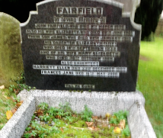Ref: F/559 – **FAIRFIELD**

In loving memory of JOHN FAIRFIELD, who died 9th March 1890. Also his wife ELIZABETH, who died 29th June 1905. Their son JAMES, who died 29th January 1919, his daughter ELIZABETH (LILY), who died 18th September 1933, and of his wife ELIZABETH, who died 30th October 1966. *“Till He come.”*

Ref: F/560 – **JOHNSTON/HALLIDAY** (Unmarked)

Ref: F/561 – **COLLINS** (Unmarked)

Ref: F/562 – **COUSINS** (Unmarked)

Ref: F/563 – **McCOLLUM** (Unmarked)

Ref: F/564 – Vacant

Ref: F/565 – **CASSIDY/CARTER** (Unmarked)

Ref: F/566 – **COOPER** (Unmarked)

Ref: F/567 – **McKEOWN** (Unmarked)

Ref: F/568 – **McCOLLUM** (Unmarked)

Ref: F/569 – **HAMILTON**

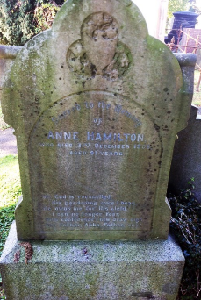

Sacred to the memory of ANNE HAMILTON, who died 31st December 1908, aged 51 years. *“My God is reconciled, His pardoning voice I hear, He knows me for His child, I can no longer fear, With confidence, I now draw nigh, and “Father, Abba, Father” cry.”*

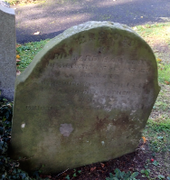Erected by RICHARD HAMILTON in memory of his father Richard who died May 12th 1847. Also his mother JANE who died 5th January 1887(?)

Ref: F/570 – **WHITE/DOBSON** (Unmarked)

Ref: F/571 - **McCONNELL** (Unmarked) Interments: 27/09/1934; 08/07/1940; 23/01/1944; 30/08/1975; 15/12/1985

Ref: F/572 – **ROBINSON** (Unmarked)

Ref: F/573 – **ADDY**

Here lieth the body of EDWARD ADDY who departed ye life 12th June 174- aged 12 years. Also ROBERT and MARY and ELIZABETH departed ye life in 1745. Children of ROBERT ADDY and ANN ADDY.

Ref: F/574 – **ROBINSON** (Unmarked)

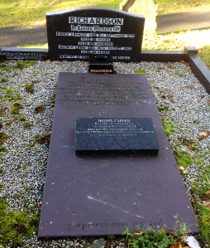Ref: F/575 – **RICHARDSON**

In loving memory of EUNICE FRANCES, died 8th September 1979 aged 88 years. Also her husband ALFRED EDWIN died 26th August 1993 aged 101*. “Worthy of everlasting remembrance.”*

*Side panel*: FRANCIS WILLIAM CAPPER, died 4th July 1924.

*Large Slab*: Erected by ARTHUR CAPPER of Tullygally in memory of his wife MARGARET who departed this life on the 11th February 1839 aged 46, also his daughter MARGARET who died on the 28th September 1838 aged 14 yeras (sic). *“Prepare to meet thy God.”*

*Small slab*: ISOBEL CAPPER dearly loved wife of FRANCIS WILLIAM CAPPER and loving mother of EUNICE died in Pietersburg, S. Africa 1873 aged – years.

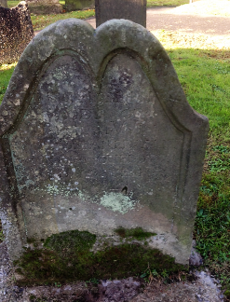Ref: F/576 – **WINN**

Here lieth ye body of JEREMIAH WINN who departed ye life – of November 1727 aged 62 years

Ref: F/577 – **STEVENSON**

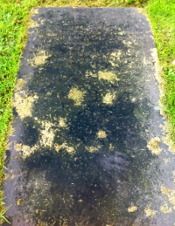Here lieth the body of SARAH STEVENSON who departed this life on the 22nd day of December 1837 aged 31 years, and also that of her husband JOHN STEVENSON who followed her to the tomb on 23rd day of December 1837 aged 37 years. *“Lovely and pleasant were they in their lives and in their death they were not divided.”* WILLIAM JOHN STEVENSON died 19th March 1897.

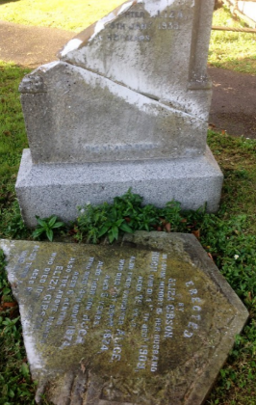Ref: F/578 – **GIBSON**

Erected by ELIZA GIBSON in loving memory of her husband HUGH, who die 17th December 1909 aged 85 years. Also their daughter ALICE, who die 21st September 1874 aged 5 years. Also their son HUGH who died 14th November 1874 aged 6 months. Also the above ELIZA GIBSON, who died 1oth April 1916 aged 80 years. Also their daughter ELIZA who died 23rd January 1935 aged 63 years. “*Be ye also ready.”*

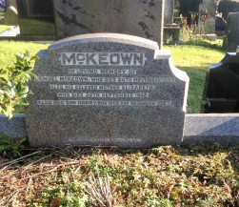Ref: F/579 – **McKEOWN**

In loving memory of SAMUEL McKEOWN who died 24th November 1907, also his beloved mother ELIZABETH, who died 30th September 1948, also her son HARRY, who died 2nd December 1967. “*The Golden Gates are lifted up*.”

Ref: F/580 – **McCLATCHEY** (Unmarked)

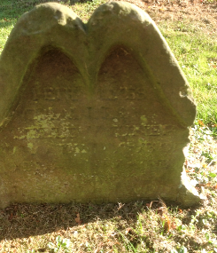Ref: F/581- **BELLEN**

Here lies CHARLES BELLEN UNER who died ye 13th of October 1721 aged 4 months. Also JANE BELLEN died ye 18th of July 1727 aged 3 years.

Ref: F/582 – **McCANN** (Unmarked)

Ref: F/583 – **McCORRY** (Unmarked) Thompson McCorry

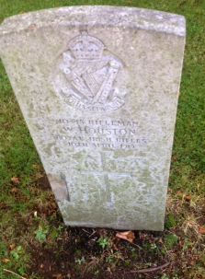Ref: F/583 – **HOUSTON**

QUIS SEPARABIT.

10445 Rifleman W. HOUSTON,

Royal Irish Rifles,

10th April 1919

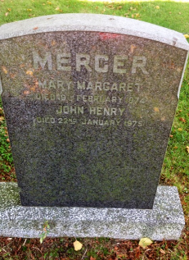Ref: F/583 **MERCER**

MERCER

MARY MARGARET died 19th February 1974 JOHN HENRY died 22nd January 1975

Ref: F/583 – **ANDERNSON & MORRISON**

Ref: F/583 – **CAMPBELL** (Unmarked)

Ref: F/584 – Vacant

Ref: F/585 – Space

Ref: F/586 – **MAHAFFY** (Belfast)/**WILSON** (Unmarked)

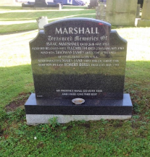Ref: F/587 – **HIGGINS/MARSHALL**

Treasured memories of ISAAC MARSHALL died 26th May 1953. Also his beloved wife ELIZABETH died 22nd January 1981. Also son THOMAS JAMES died 23rd April 1984 at Westwood, Mass., USA. Also daughter MARY JANE died 30th October 1986. Also son-in-law ROBERT BERRY died 12th May 1993. *“My presence shall go with thee and I will give thee rest.”*

Ref: F/588 – **THOMPSON** (Unmarked)

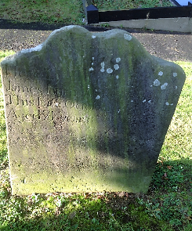Ref: F/589 – **BYRNE** IHS

Here lieth the body of JAMES BYRNE who departed this life October 14th 1784 aged 71 years.

Ref: F/590 – **McNEILL**

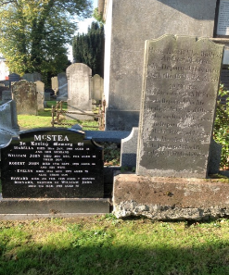Ref: F/591 **McSTEA**

*Right stone*: Here lieth the body of ANDREW McSTEA who departed this life April 15th 1822 aged 40 years. Also his wife SARAH McSTEA who departed this life July the 5th 1848 aged 70 years. Also his son DANIEL McSTEA who departed this life July 16th 1851 aged 42 years and also his wife JANE McSTEA who departed this life June the 25th 1870 aged 56 years.

*Left stone*: In loving memory of ISABELLA died 16th January 1904 aged 38 and her husband WILLIAM JOHN died14th December 1914 aged 80, Their son ROBERT JOHN died 17th September 1970 aged 84, Also his wife EVELYN died 15th August 1971 aged 78. Also their son HOWARD died 2nd February 1928 aged 7 months. BERNARD brother of WILLIAM JOHN died 4th March 1905 aged 75.

Ref: F/592 – Vacant

Ref: F/593 – **RUDDY** (Unmarked)

Ref: F/594 – **GORMAN**  (Unmarked)

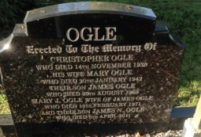Ref: F/595 – **OGLE**

Erected to the memory of CHRISTOPHER OGLE who died 14th November 1938. His wife MARY OGLE who died 20th January 1942, their son JAMES OGLE died 20th August 1969. MARY J. OGLE, wife of JAMES OGLE, who died 18th February 1971 and their son JAMES N. OGLE who died 5th April 2011.

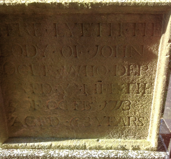

Left stone: Here lieth the body of JOHN OGLE who departed ye life 3rd of October 1713 aged 63 years.

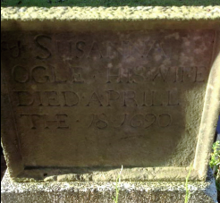 Right stone: SUSANNA OGLE, his wife, died April 18th 1690.

(Oldest stone in the graveyard)

Ref: F/596 – **ROBINSON**  (Unmarked)

Ref: F/597 – **RODGERS**  (Unmarked)

Ref: F/598 – **THOMPSON** (Unmarked)

Ref: F/599 – **THOMPSON** (Unmarked)

Ref: F/600 Vacant

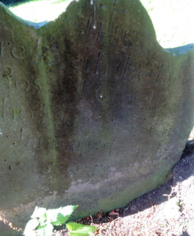Ref: F/601 – **McCAUGHELY** IHS

Here lieth the body of ROSE McCAUGHELY who departed this life January 12th 179- aged 61 years.

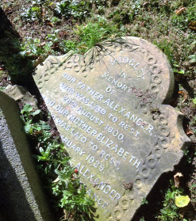Ref: F/602 - **MIDGLEY**

In memory of our father ALEXANDER who was laid to rest 29th August 1900. Also our mother ELIZABETH who was laid to rest 9th February 1929 and our brother ALEXANDER who was killed in France 6th July 1917*. “A noble father and a perfect mother.” “In grateful love.”*

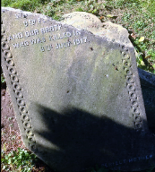

Ref: F/603 Vacant

Ref: F/604 – **BLAIR** W. Blair (Nancy B..) Interments 12/03/1933; 26/1/1933; 22/01/1962

Ref: F/605 – Vacant

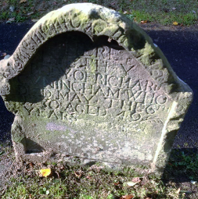Ref: F/606 – **CUNNINGHAM**

Here lieth ye body of RICHARD CUNNINGHAM who died May the 6th 1730 aged 49 years.

Ref: F/607 – **BRYANS**

The family burying ground of WILLIAM JAMES BRYANS.

Ref: F/608 Vacant

Ref: F/609 – **NICHOLSON**

Ref: F/610 – **MORRISON/MARTIN** of Moyraverty

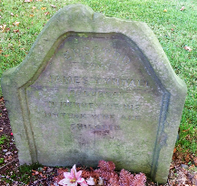Ref: F/611 – **TINDALL**

Erected by JAMES TYNDALL of Lurgan in memory of his mother, wife and children.

Ref: F/612 Vacant

Ref: F/613 Vacant

Ref: F/614 – **BUSHE** (Unmarked)

Ref: F/615 – **HAMILTON** (Unmarked)

Ref: F/616 – **BEST**

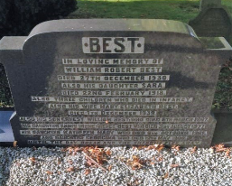In loving memory of WILLIAM ROBERT BEST died 27th December 1930. Also his daughter SARA died 22nd February 1918. Also their children who died in infancy. Also his wife MARY ELIZABETH BEST died 7th December 1939. Also his son ERNEST WILLIAM BEST who died 6th March 1967. His daughter ANNIE IRENE (RENEE) BEST who died 31st August 1977, hi daughter KATHLEEN MARY who died 8th October 1981 and daughter GEORGINA who died 12th May 1986. *“Until the day break and the shadows flee away.”*

Ref: F/617 – **KILLPATRICK**

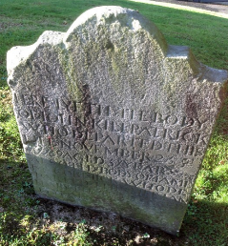Here lieth the body of JOHN KILLPATRICK who departed this life November 25th aged 51 (or 57). Also the body of FIAME McCORMICK who departed this life January the 14th 1766 aged 73 years.

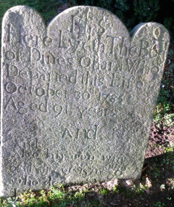**O’HARA**

Here lieth the body of DINES O’HARA who departed this life October 30th 1785 aged 51 years and also his son WIN O’HARA of Kynego who died ------------.

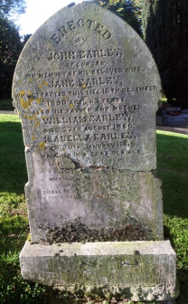Ref: F/618 – **EARLEY**

Erected by JOHN EARLEY of Lurgan in memory of his beloved wife JANE EARLEY who departed this life 16th December 1890 aged 63 years. Also his father and mother WILLIAM EARLEY died 27th August 1866, ISABELLA EARLEY died 20th January 1868 --------- in a good old age. Also above named JOHN EARLEY who died 18th April 1897 aged -0 years. *“I shall be satisfied when I awake with thy likeness.”* Pr 17.15

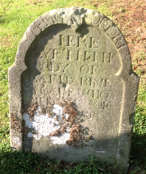**McCALL**

Here lieth ye body of KATHERINE McCALL who died ye 1-th of March 1705.

Ref: F/619 Vacant

Ref: F/620 – **McCOY** (Unmarked) Interment: 09/09/1960

Ref: F/621 – **HAGAN** (Unmarked)

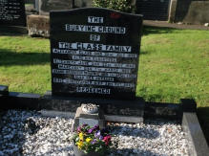Ref: F/622 – **GLASS**

The burying ground of the GLASS Family

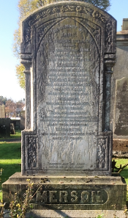Ref: F/623 – **EMERSON**

In memory of JANE, wife of THOMAS EMERSON of Lurgan, who died16th May 1888 aged 66 years. Also their daughter ISABELLA who died in infancy, and of her husband THOMAS EMERSON, who died 19th March 1892 aged 66 years. Also their only son WILLIAM, who died 19th June 1911 aged 62 years. *“Lead kindly light. To rest forever after earthly strife in the calm light of everlasting life*.” Also their daughter ELIZABETH, who died 11th December 1926 aged 79 years, “*Blessed are the dead who die in the Lord.”*

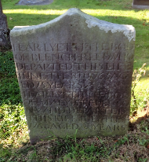Ref: F/624 – **REED**

Here lyeth the body of BLENCH REED who departed this life June the 8th 1765 aged 75 years.

Here lyeth the body of MARY STEENSON who departed this life July the 2nd 1766 aged 22 years.

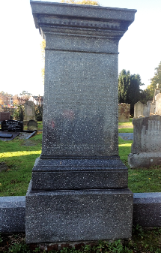Ref: F/624 – **ROSS**

ROBERT ROSS died 29th July 1872 in the 50th year of his age. His son ROBERT died 20th November 1867 aged 6 years. His daughter JANE died 4th July 1899. JANE ROSS, wife of ROBERT ROSS died 27th October 1908 aged 85 years. His daughter ELIZA died 17th November 1916. His son WILLIAM died 13th January 1928. His daughter MARY died 24th August 1939. His son HUGH died 16th June 1941.

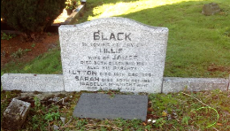Ref: F/626 – **BLACK**

In loving memory of LILLIE, wife of JAMES, died 30th December 1967. Also his parents LUTTON, died 15th December 1901. SARAH, died 30th December 1931. ISABELLA McKNIGHT (aunt) died 22nd December 1935. “*Till He come.” Small plaque reads*: JAMES BLACK, died 12th January 1982. Their son, JAMES DENNIS BLACK died 22nd --------- 1986.

**HUNTER** (Knocknashane)

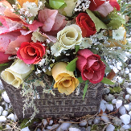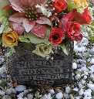Memorial vases read: In loving memory of CATHERINE HUNTER died 13th May 1960. In loving memory of WILLIAM HUNTER died 6th October 1975. In loving memory of ANNIE MORRISON died 10th March 1973.

Ref: F/627 – **BELL** (Unmarked)

Ref: F/628 – **SMITH** (Unmarked)

Ref: F/629 - Vacant

Ref: F/630 – Vacant

Ref: F/631 – Vacant

Ref: F/632 – **MARTIN** (Unmarked)

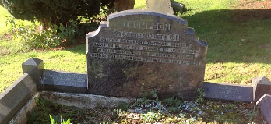Ref: F/633 – **THOMPSON**

In loving memory of Flight Sergeant THOMAS WILLIAM, lost in flight off Burma 1st June 1944. Also his dear father THOMAS WILLIAM who died 29th May 1968 aged 85 years. Side walls: ROBERT THOMPSON, William Street, Lurgan, died 20th October 1969. His wife MARY JANE died 10th April 19--.

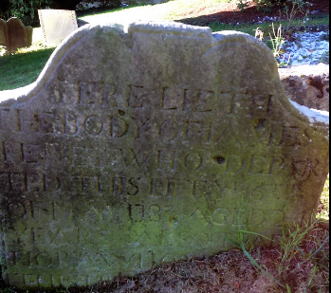Ref: F/634 – **HENEY**

Here lyeth the body of JAMES HENEY who departed this life ye 16th of May 179- aged 24 years. Also MARY HORAW who departed ------------- (rest of stone buried in the ground).

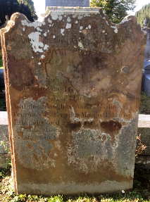Ref: F/635 – **ROSS**

Erected by ANNA ROSS in memory of her husband JAMES ROSS who departed this life 23rd October 184- aged 46 years. And her father DENI---- ---------- who departed this life 16th -------- 18-- aged 71 years. Also their daughter ANNA who died 9th April 1832 aged 18 months; likewise ELLEN who died 2nd May 1813 aged 8 years. Also his daughter MARGARET ROSS who died 8th March 1885 aged 92 years.

Ref: F/636 – **JONES**

Ref: F/637 – **SANDS**

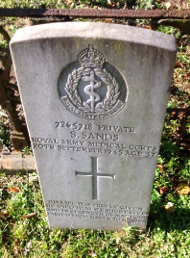7726518 Private

S.SANDS,

Royal Army Medical Corps,

20th September 1945 aged 37 years.

*“His life was freely given. He died that we might live and in strength of manhood passed from earth to heaven.”*

Ref: F/638 – **FARRELL** (Unmarked)

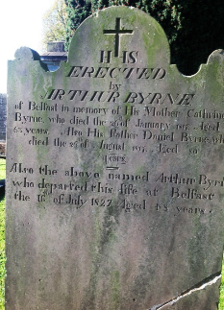Ref: F/639 – **BYRNE** I.H.S

Erected by ARTHUR BYRNE of Belfast in memory of his mother CATHERINE who died the 26th of January 1817 aged 63 years. Also his father DANIEL BYRNE who died the 26th of August 1817 aged 80 years. Also the above named ARTHUR BYRNE who departed this life at Belfast the 16th of July 1847 aged 48 years.

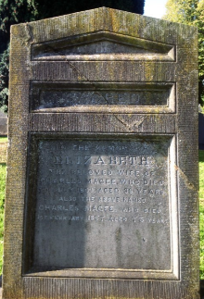Ref: F/640 – **MAGEE**

Sacred to the memory of ELIZABETH, the beloved wife of CHARLES MAGEE, who died 6th July 1863 aged 33 years. Also the above named CHARLES, who died 1st February 1877 aged 73 years.

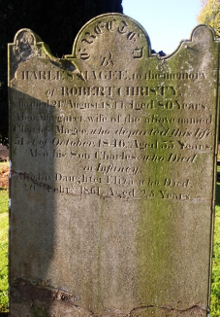*Second stone:* Erected by Charles Magee to the memory of ROBERT CHRISTIE, who died 21st August 1844 aged 80 years. Also MARGARET, wife of the above named CHARLES MAGEE, who departed this life 31st October 1846 aged 33 years. Also his son CHARLES who died in infancy. Also his daughter ELIZA died 20th February 1861 aged 25 years.

Ref: F/641 – **WRIGHT/HAUGHEY** (Unmarked)

Ref: F/642 – **McALEC & PENTLAND** (Unmarked)

Ref: F/643 – Vacant

Ref: F/644 – **CARVILLE**

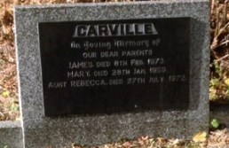In loving memory of our dear parents JAMES, died 8th February 1973, MARY, died 28th January 1959. Aunt REBECCA, died 27th July 1972.

Ref: F/645 – **CORDNER**

Ref: F/646 – Vacant

Ref: F/647 – **BROWN**

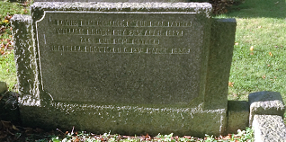In loving memory of our dear father WILLIAM BROWN, died 28th April 1927. Also our dear mother, ISABELLA BROWN, died 13th March 1936.

Ref: F/648 – Vacant

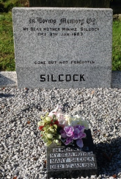Ref: F/649 – **BUSH/SILCOCK**

In loving memory of my dear mother MARY SILCOCK, died 9th January 1983

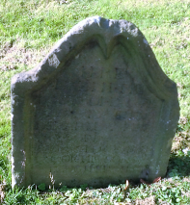Ref: F/650 – **McDAVID**

Here lyeth the body of DANIEL McDAVID who departed ye life ye 29th of January 1776 aged 52 years, wife and 5 sons and 3 daughters.

Ref: F/651 – **LENAN**

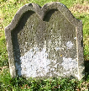Here lyeth the body of JOHN LENAN who departed ye life ye 17th of March ----

Ref: F/652 – **MORRISON**

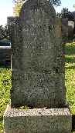Erected in memory of THOMAS MORRISON of Lurgan who died 9th January 1888 aged 62 years. Also his wife ELLEN, who died 9th May 1888.

Ref: F/653 – Vacant

Ref: F/654 – Vacant

Ref: F/655 – **THOMPSON** (Unmarked)

Ref: F/656 – **WATSON** (Unmarked)

Ref: F/657 – Vacant

Ref: F/658 – Vacant

Ref: F/659 – **TIMOTHY** (Unmarked)

Ref: F/660 – **PEDLOW** (Unmarked)

Ref: F/661 – **IRWIN**

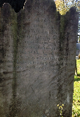Sacred to the memory of ROBERT IRWIN who departed this life 31st August 1833 aged 65 years. Also his son WILLIAM who departed this life the 2nd August 1840 aged 20 years. Likewise his son JAMES IRWIN who died 9th August 1842 aged 26 years and MARY IRWIN wife of the above named ROBERT IRWIN who died 27th January 1848 aged 70 years.

Ref: F/662 – **BONIS** (Unmarked)

Ref: F/663 – **POLAND** (Unmarked)

Ref: F/664 – **DORAN**

Here lies ye body of OWEN DORAN, who departed this life ye 26 of August 1752 aged 60 years.

Ref: F/665 – **PATTERSON** (Unmarked)

Ref: F/666 – Vacant

Ref: F/667 – **MAGUIRE** (Unmarked)

Ref: F/668

Ref: F/669 – **McDOWELL**

Ref: F/670 – Vacant

Ref: G/671 – Vacant

Ref: G/672 – **BURNS**

Here lieth the remains of THOMAS

Ref: G/673 – **WATKINS**

Here lyeth the body of ANN WATKINS who departed this life March the 3rd 1774 aged 14 years,

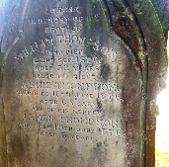Ref: G/674 – **THOMPSON**

Erected by ROBERT THOMPSON of Lurgan in memory of his brother WILLIAM THOMPSON who died 22nd September 1876 aged 32 years. Also his niece ANNIE THOMPSON who died 16th June 1876 aged 6 year and of his nephew JAMES THOMPSON who died 19th June 1876 aged 3 years.

Ref: G/675 – **LUNN**

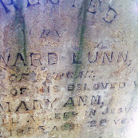Erected by EDWARD LUNN of Lurgan in memory of his beloved wife MARY ANN who fell asleep in Jesus 2nd January 1885 aged 28 years.

Between 675 &676

Here lieth the body of JOHN ------------ who departed this life the 28th --------- 1883 aged – years.

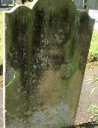Ref: G/676 – **NICHOLSON**

Erected by ROBERT NICHOLSON of Tullygally in memory of his beloved wife MARGARET who departed this life 22nd June 1864 aged 74 years. Also his daughter MARTHA who departed this life ---- October 1869 aged 37 years. Also the above named ROBERT NICHOLSON who departed this life 24th May 1877 aged 85 years.

Ref: G/677 – **FOX & SANDS** (Unmarked)

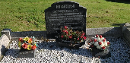Ref: G/678 – **ARCHER**

In loving memory of JOSEPH ARCHER died 24th November 1944. Also his wife ANNIE BARBARA died 19th October 1955. Also their daughter ENA who died 9th May 1913. *“The Lord is my Shepherd.”*

Ref: G/679 – **SOYE**

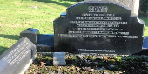In loving memory of our dear mother ANNIE SOYE, died 7th April1934 aged 84 years. Also their daughter LILIAN, died 9th May 1901. Also their son WILLIAM died in Detroit, U.S.A. 28th February 1928. “The Lord is my Shepherd.” On surround: ANNIE, beloved wife of FREDERICK A. SOYE, who died 15th April 1950. JAMES SOYE, died 2nd October 1975. Also his wife EVELINE, died 10th August 1979.

Ref: G/680 – **THOMPSON** (Unmarked)

Ref: G/681 – **GORDON**

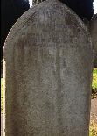Erected by MARY ANN GORDON, Boconnel, in memory of her beloved husband THOMAS GORDON died 3rd March 1884 aged 63 years,

Ref: G/682 **LAVERY** (Unmarked)

Ref: G/683 **LAVERY** (Unmarked)

Ref: G/684 Not on map (Unclaimed)

Ref: G/685 (Unclaimed)

Ref: G/686 – **MALCOLMSON**

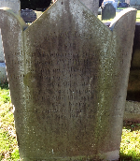Erected by ARTHUR MALCOLMSON in memory of his beloved father who died at his own residence in Ballinamoney 23rd November 1865 aged 66 years. Also JAMES MALCOLMSON who died 11th April 1911 aged 60 years. Also MARY, wife of the above JAMES MALCOLMSON who died 23rd May 1921 aged 61 years.

Ref: G/687 – **KERR/GORDON/LUNN/MITCHELL** (Unmarked)

Ref: G/688 – (Unclaimed)

Ref: G/689 – **TAYLOR/RIPON** (Unmarked)

Ref: G/690 – **FERRIS** (Unmarked)

Ref: G/691 – **McMULLEN** (Unmarked)

Ref: G/692 – **NESBITT** (Unmarked)

Ref: G/693 – **MCGEE/KINKEDD** (Unmarked)

Ref: G/694 – **CARSON** (Unmarked)

Ref: G/695 – Vacant

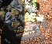Ref: G/696 – **NESBITT**

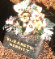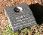 Memorial vases on grave read: ELIZABETH NESBITT; THOMAS J. NESBITT and ALBERT died 3.11.1992 JOSEPHINE died 18.2.1996

Ref: G/697 – **NESBITT**

 Memorial vases on grave read: ELIZABETH NESBITT; THOMAS J. NESBITT and ALBERT died 3.11.1992 JOSEPHINE died 18.2.1996

Ref: G/698 – **WELLS** (Unmarked)

Ref: G/699 – **CAMPBELL** (Unmarked)

Ref: G/700 – (Unclaimed)

Ref: G/701 – (Unclaimed)

Ref: G/702 – **DOUIE**

Ref: G/703 – **McNIECE**

275556 Gunner

D. McNEICE

Royal Garrison Artillery

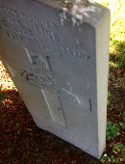28th July 1918

Ref: G/704 – **KENNEDY** (Unmarked)

Ref: G/705 – **DORAN** (Unmarked)

Ref: G/706 – **McMULLAN** (Unmarked)

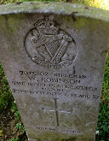Ref: G/707 – **ROBINSON**

“*QUIS SEPARABIT”*

0013802 Rifleman

W. ROBINSON

The Royal Ulster Rifles Airbourne

23rd September 1943

Age 27

“*LEST WE FORGET”*

Ref: G/709 – **THOMPSON** (Unmarked)

Ref: G/710 – **CARROLL**

Ref: G/711 – **FITZSIMONS** (Unmarked)

Ref: G/712 - **WALKER**

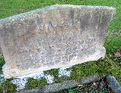In loving memory of our dear mother MARGARET ANN, beloved wife of THOMAS WALKER called Home 7th October 1941. Also the above named THOMAS WALKER who departed this life 5th December 1953 aged 80 years.

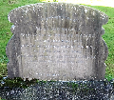In loving memory of MARY ANN WALKER, beloved wife of ROBERT WALKER, who died 26th March 1945. Also the above named ROBERT WALKER, who died 12th July 1945. Also their youngest son WILLIAM ROBERT, who died 11th December 1964. “*Till we meet again*.”

Ref: G/713 – **CASTLES**  (Unmarked) Robert Castles

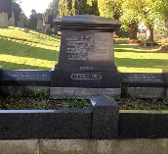Ref: G/714 - **MALCOLM**

In loving memory of JAMES MALCOLM D.L. died 6th January 1910 aged 53 years. Also his wife ELIZA MALCOLM, died 17th May 1923 aged 78 years. Also their daughter CHARLOTTE ELIZABETH PATTERNSON, died 24th April 1932 aged 58 years. Also their son HERBERT CECIL MALCOLM, died 14th November 1946 aged 61 years. “*Till He come*.” Inscription on surround reads: And their daughter MARY JANE WATSON born 18th May 1870 died 15th November 1960 and their daughter ETHEL ANNIE MALCOLM born 20th May 1876, died 1st January 1949.

Ref: G/715 – (Unclaimed)

Ref: G/716 – **WRIGHT & SULLIVAN** (Unmarked)

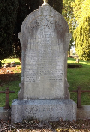Ref: G/717 – **CAMPBELL**

Erected by JAMES CAMPBELL of Lurgan in loving memory of his infant son JAMES, who died 13th July 1855 aged 11 months. Also his beloved daughter MARTHA who died 29th March 1875 aged 14 years. Also WILLIAM, fifth son, died in Brooklyn 29th November 1896, buried Greenwood Cemetery U.S.A. and the above named JAMES CAMPBELL died 14th January 1899 in his 70th year. “*Father in Thy gracious keeping, leave me now, Thy servant sleeping*.” HARRIET, beloved wife of above named died 30th May 1907. *“Dearest of mothers*.” ROBERT ROSS, third son, died 16th February 1908; THOMAS RINGLANE, eldest son, died 11th October 1911; CHARLES WESLEY, sixth son, died 18th October 1921. ALICE ANNE, youngest daughter, died 8th May 1935; SAMUEL, youngest son, died 5th February 1936; JAMES, died 18th January 1938; HENRIETTA died 14th August 1938. *“We love Him because He first loved us.”*

Ref: G/718 – **WRIGHT & CAMPBELL/LECKEY** (Unmarked)

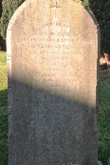Ref: G/719 – **McGUIGAN**

Erected by ELIZA McGUIGAN in memory of her beloved husband BERNARD McGUIGAN, who departed this life July 8th 1897 aged 67 years. Also his seven children who died in infancy. Also the above named ELIZA McGUIGAN who died 8th September 1899. Also their son HUGH who died 21st September 1937.

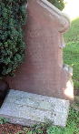Ref: G/720 – **BULLICK**

In affectionate remembrance of MARY ANNE BULLICK died 28th June 1851. MARY BULLICK died 23rd September 1880. *“My heart and my flesh faileth but God is the strength of my heart and my portion forever*.” SAMUEL COMERFORD BULLICK died 4th January 1881 age 12 years and 5 months. “*God is love*.” Also WILLIAM BULLICK who died 5th September 1889 aged 75 years. Also THOMAS BULLICK, son of above, who died 5th May 1872 aged 27 years.